# NHS Pensions Online (POL) Guide

# 3. Registration process

# 

# For those employers who do not yet have access to Pensions Online, select the ‘Register’ link and this will take you through the online registration process.

You access Pensions Online via the home page of the NHSBSA website, [www.nhsbsa.nhs.uk/nhs-pensions](http://www.nhsbsa.nhs.uk/nhs-pensions), you will find the link to the portal within the employer hub section of the website

Only one registration per National Health Service Business Services Authority (NHSBSA) employer is allowed and this initial registration **must** be completed by the Pensions Manager or other nominated person with suitable authority. Once registration is completed then other users can be added. More information on this can be found in the POL guide 7 – administer employer access

The electronic registration form is available via the **‘Register’** link

Once selected you will be asked to insert your Employing Authority code or GP Practice code (EA code), as follows:

If you select this link and your Authority or GP Practice already has access to Pensions Online you will receive the onscreen message:

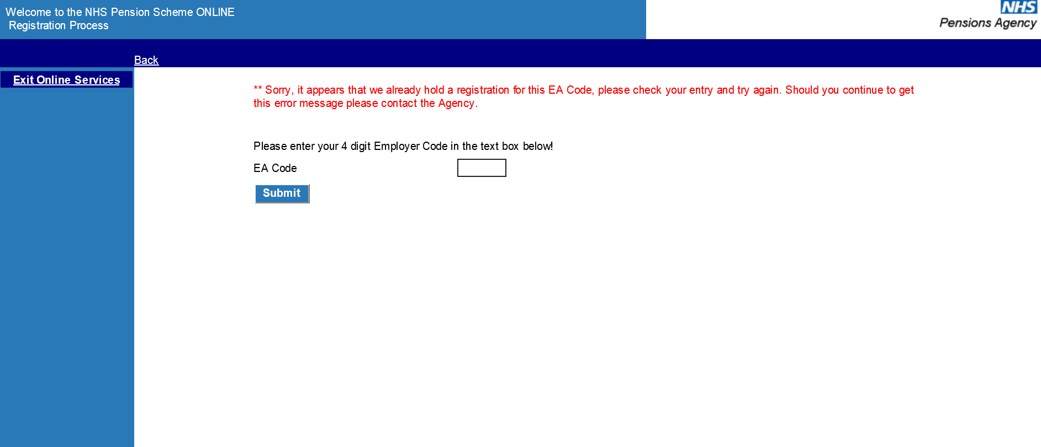

If this is the first registration you will continue to the next stage, as follows:

Once you have fully completed the form and selected ‘verify’ at the bottom of the page you will receive a confirmation page requesting that you print the page and arrange for it to be countersigned by the Local Pensions Online Administrator's Board level manager or Principal Practitioner, for GP Practices.

The countersigned form should then be scanned and e-mailed to [polhd@nhsbsa.nhs.uk](mailto:polhd@nhsbsa.nhs.uk)

Example of confirmation page:

The NHSBSA will then verify the application and you will be issued with a pin and password. Details of how you can then register other users are contained in the guide **‘Administer Employer Access’**, in the section for **‘Add New Access Rights’.**

You will then receive an email with details of your pin number containing an icon called **‘Read Me’** – click on this icon for further details. Once you have received your PIN number please e-mail pensions online helpdesk confirming you pin number and they will provide the password You should change the password to one that you will easily remember, which you should then keep safe and never divulge to any one else.

Once a copy of the registration form is received by the NHSBSA it generally takes 3-4 working days before you can get access to the system.

**Important note**: If you have any problems with the registration process please contact the Pensions Online Helpdesk via e-mail [polhd@nhsbsa.nhs.uk](mailto:polhd@nhsbsa.nhs.uk) .

For employers or third party administrators that have access the the HSCN network, that do not have access to a NHS.net e-mail account please e-mail the POL helpdesk, who will assist you with accessing the system.