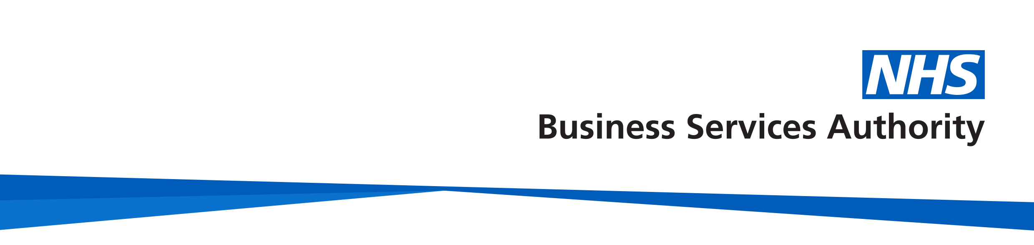

# NHS Pensions

# 

# Bereavement Video

# NHS Pensions – Bereavement Video

## Video Transcript

In the event of your death, the NHS Pension Scheme may provide for your family or a person you have nominated.

The benefits payable will depend on the Scheme you were in and your circumstances at the time of your death.

The lump sum on death benefit will be paid to your spouse, registered civil partner, or Scheme partner unless you nominate someone else to receive it.

If you have dependant children, then a children’s pension may be payable.

Please read the Survivors Guide and the information in the ‘Bereavements’ area of our website for more information about:

* Death benefits
* How to apply for survivor benefits

[www.nhsbsa.nhs.uk/nhs-pensions](http://www.nhsbsa.nhs.uk/nhs-pensions)

This information is correct as of February 2025.

**How we use your information**

For more information about how the NHSBSA processes your personal data, see our privacy notice - [www.nhsbsa.nhs.uk/our-policies/privacy/nhs-pensions-privacy-notice](http://www.nhsbsa.nhs.uk/our-policies/privacy/nhs-pensions-privacy-notice)

**NHS Pensions**

**Bereavement Video Transcript**

[www.nhsbsa.nhs.uk/nhs-pensions](http://www.nhsbsa.nhs.uk/nhs-pensions)