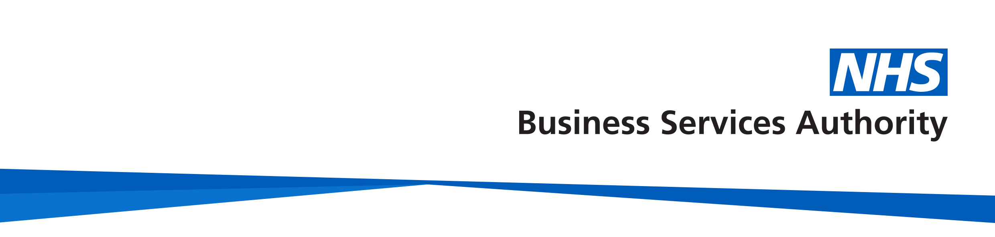

# NHS Pensions

# 

# Employer factsheet

# NHS Pensions - Children’s pension

## Death in membership or within 12 months of leaving pensionable employment

In this document, you will find information on children’s pensions where a member has died in membership or within 12 months of leaving pensionable employment.

This information relates to cases where a member has died on or after 1 April 2008 and had membership on or after 1 April 2008. If you need information on what to do if the member died before 1 April 2008, contact us to discuss.

**Leaving pensionable employment**

Leaving pensionable employment means where a member has opted out of the Scheme but carried on working in the NHS, or where they have left NHS employment. In these circumstances if the former member then dies within 12 months, the children’s pension is calculated in the same was as if the member had died in service.

Leaving pensionable employment does not refer to a member who has transferred their benefits out of the Scheme, or to members who are in receipt of their pensions.

**When a children’s pension is payable**

A children’s pension may be payable when a Scheme member dies if:

* the child was dependant on the member at the date of death or, if the member died within 12 months of leaving pensionable employment, the child was dependant on the member when the member ceased pensionable employment; and
* the child is under age 23; or
* the child is aged 23 and over and unable to earn their own living due to a permanent physical or mental condition, which they were suffering at the time the member died. The child will be treated as a dependent child for as long as they remain incapable of earning a living

If a child is aged over 23, we will ask to see a medical certificate or letter from the child’s

doctor explaining their condition. The medical evidence will be sent to the Scheme’s

medical advisors to assess eligibility.

**Important note**: the child must have been suffering from their medical condition at the

time the member died for eligibility to be considered.

**A dependant child**

This is a child, or children, who are dependent on the member.

This does not have to be the member’s own child or children. It can include a number of other possible child dependants:

* a biological child
* a stepchild by a marriage or a civil partnership entered into before the date the member died in pensionable employment
* a stepchild by a marriage or a civil partnership entered into before the date the member leaves pensionable employment
* a child legally adopted by the member before they died in pensionable employment or left pensionable employment
* a child who, immediately before the member died or left pensionable employment, the member had intended to adopt
* a biological grandchild
* a brother or sister, of the member or the member’s spouse, civil partner or qualifying scheme partner
* any half brother or half sister and any step brother or step sister being treated as a brother or sister for this purpose
* a nephew or niece of the member or of their spouse, civil partner or qualifying scheme partner
* a child who, at that time the member died or left pensionable employment had been dependant on the member for 2 years or (if less) half the child’s life

a child who was dependant on the member before the member left pensionable employment **and** when the member died

* a child who is born one year or less after the member left pensionable employment and who is either dependant on the member at the time of being born **and** when the member died or would have been dependant on the member had the member not died before the child was born
* a child of a member's qualifying scheme partner (see definition below) who meets the specific criteria for payment at the date of death or the date the member left pensionable employment.

A qualifying scheme partner is someone who for a continuous period of at least 2 years ending with the member’s death:

* was living together with the member in the same household as if they were married or civil partners
* they and the member were free to marry or enter into a civil partnership
* they were financially interdependent with the member or financially dependent on the member
* neither was living with someone else as if they were married or in a civil partnership.

**Calculating the children’s pension**

A children’s pension can be paid for eligible dependent children if the member has contributed to the Scheme. There is no minimum qualifying service required.

The children’s pension is based on the greater of:

* the pension the member would have been entitled to had they retired and qualified for a tier 2 ill health pension on the date they died
* a pension based on 10 years membership.

If the member worked part time during their employment the children’s pension will be calculated using scaled service and whole-time equivalent pay. It will be increased in line with the provisions relevant to the Section or Scheme the member was contributing to when they died.

If the deceased member bought additional pension with dependants cover, the surviving child is also entitled to a proportion of 75% of the deceased’s additional pension.

The amount of children’s pension payable will depend on what Scheme the member was in before they died, the number of eligible dependent children, whether there is a surviving parent who is entitled to an adult dependant’s pension. More information can be found in the life assurance and family benefits section in the 1995/2008 and 2015 guide for members, which can be found on our website [www.nhsbsa.nhs.uk/nhs-pensions](http://www.nhsbsa.nhs.uk/nhs-pensions).

Where the member was in more than one NHS Pension Scheme, or more than one Section of the NHS Pension Scheme, the proportions are more complex. If you need further information you should contact us.

Where there are children from a former relationship each parent can claim a children’s pension, but the proportions paid are more complex and depend on the number of families and the number of eligible children. If you need information about how a pension is split between families, contact us for further information.

### Children’s pension adjustments

Adjustments can be made to a children’s pension in payment if information is received that changes the amount to be paid, or the proportion of children’s pension payable if there is more than one child.

The amount being paid may be adjusted if later information confirms that:

* a children’s pension is being paid on the basis that a child was an eligible child but in fact the child was not eligible for the payment, or
* on the member’s date of death there was an additional eligible child, or an eligible child was born after the member’s death (that is, was born not more than 12 months after the member ceased pensionable employment); or
* a claimant declared that the deceased was single when in fact they were married, in a civil partnership, or had an eligible scheme partner.

This takes into consideration that multiple family units may exist and beneficiaries are not aware of each other’s existence.

**When the children’s pension is payable from**

For death in membership cases only, the children’s pension is payable from the day after the date of death. However, an initial children’s pension may be paid where the child is not dependent on a surviving adult who is entitled to a pension, or there is a surviving adult, but no pension is payable. The initial children’s pension is paid for a period of:

* 3 months starting on the day after the member’s death where an adult dependant’s pension is payable, but the child is not dependent on that adult survivor, that is, because they are from a previous marriage or relationship
* or 6 months starting on the day after the member’s death where there is no adult dependant’s pension payable.

An initial pension is not payable if the member died within 12 months of leaving the Scheme.

**Notifying us of dependent children**

Indicate on the death in service notification form whether the member had a dependant child or children. We will issue a dependant claim form (DCF).

We will check eligibility and pay any children’s pension that might become payable which can be paid to the person who has care of the child(ren) or the child’s own bank account, even if they are a minor.

**Tax**

A children's pension paid to a parent, stepparent or guardian is not regarded as part of the adult’s income for tax purposes.

A child gets the same personal tax allowance as an adult and must pay income tax on any children’s pension in excess of their personal allowance.

We will deduct income tax via PAYE. At the end of the tax year the child will receive a P60 from the scheme administrator showing how much income tax they have paid.

The payment of a children’s pension is not a benefit crystallisation event and therefore does not use up any lifetime allowance.

**How we use your information**

For more information about how the NHSBSA processes your personal data, see our privacy notice - [www.nhsbsa.nhs.uk/our-policies/privacy/nhs-pensions-privacy-notice](http://www.nhsbsa.nhs.uk/our-policies/privacy/nhs-pensions-privacy-notice)

**NHS Pensions**

**Employer factsheet name**

[www.nhsbsa.nhs.uk/nhs-pensions](http://www.nhsbsa.nhs.uk/nhs-pensions)