# 

**NHS Pensions**

# 2015 Scheme GP tiered contributions: Guidance notes for use of the annualisation calculator for scheme year 2023/24

## Background

As all members are in the 2015 Scheme from 1 April 2022, the tiered employee contribution rate for a medical practitioner is based on their global and annualised income. For example, GP practice plus self-employed Out of Hours (OOHs) plus self-employed integrated care board (ICB).

All breaks in pensionable service in scheme year 2023/24 must be accounted for irrespective of the type of GP or length of the break. A GP is not regarded as being in continuous pensionable service during a break.

To assist GPs, we, NHS Pensions have developed a 2023/24 annualisation calculator, in which the GP enters details of their GP work and income to determine the correct tiered employee contribution rate.

For the 2023/24 scheme year, as there was not a mid-year tiered employee contribution rate change, the calculator for 2023/24 is not required to calculate the tier rates for the 2 relevant periods as was required for the 2022/23 scheme year.

## General guidance for using the 2023/24 calculator

When using the calculator it is important to enter the type of GP work undertaken. The calculator recognises 3 different types of work, which each contribute to the total GP income used to set the tiered employee contribution rate.

## Type 1 GP

A Type 1 GP is a GP who is partner, shareholder, or single-hander.

Enter the dates and income for each period of work as a Type 1 GP.

**For example:**

A Type 1 GP who worked from 1 May 2023 to 31 March 2024 should enter the pensionable profit figure for the whole period of work.

Calculator inputs:

From 1 May 2023 to 31 March 2024

Pay = pensionable profit for the whole period (that is, 1 May 2023 – 31 March 2024).

## Type 2 GP

A Type 2 GP is a:

* salaried GP formally employed by a GP practice, alternative provider of medical services (APMS) contractor or an Local Health Board (LHB)
* long term fee based/self-employed GP who works for a GP practice, APMS contractor or LHB for a period of, generally, 6 months or more and elects to be a Type 2
* GP who works solely on a self-employed basis for an OOH provider that is an NHS Pension Scheme employing authority

Enter the dates and pensionable income for each period of work as a Type 2 GP.

**For example:**

A salaried GP who worked from 1 July 2023 to 28 February 2024 should enter one period of Type 2 work.

Calculator input:

From 1 July 2023 to 28 February 2024

Pay = actual pensionable pay for this period

## Self-employed freelance locum GP

Only enter the actual dates worked and income pensioned via the 2023/24 GP locum forms. A separate entry is required for each period of pensionable GP locum work.

Non-working days must not be declared on the forms or the calculator.

Remember that a freelance GP locum has up to 10 weeks to pension their income.

**For example:**

A GP Locum who worked from 15 May 2023 to 18 May 2023, 20 June 2023 to 23 June 2023 and 6 November 2023 to 9 November 2023 during the 2023/24 scheme year should enter 3 separate periods of GP locum work

Calculator input:

1. From 15 May 2023 to 18 May 2023

Pay = actual pensionable pay for this period

1. From 20 June 2023 to 23 June 2023

Pay = actual pensionable pay for this period

1. From 6 November 2023 to 9 November 2023

Pay = actual pensionable pay for this period

## GP SOLO (such as ad hoc) income

Where a Type 1 or 2 GP also performs SOLO work (for example, self-employed OOHs or appraisals) in addition to their ongoing main Type 1 or Type 2 post, it must not be entered in the calculator as a separate post.

The SOLO income is not annualised separately, even if the SOLO work is irregular, provided that the GP also has an ongoing Type 1 or Type 2 post.

Instead, the SOLO income is added to the Type 1 or Type 2 income before annualising occurs. This means that if the GP did not work a full 365 days in the year, the SOLO income will form part of the annualised income.

Where a GP only performs SOLO work and does not have an ongoing Type 1 or Type 2 practitioner post, their pensionable membership is determined by their contract for service arrangement as below:

1. A GP who has a continuous contract for service arrangement with the OOH’s provider has continuous pensionable service for the duration of the contract for service arrangement.

Enter the dates and pensionable income for the duration of the contracted period during the 2023/24 scheme year.

1. A GP who has individual contract for services arrangements on each occasion they work for the OOH’s provider has pensionable membership for the actual days of work only.

Enter the dates and pensionable income for each period of OOH work during the 2023/24 scheme year.

## ICB work

Although an ICB may put a self-employed GP ‘on the payroll’ so that tax and National Insurance is paid at source, they are still a practitioner in NHS Pension Scheme terms and the SOLO form must be used. The ICB must not create an officer post.

A GP who is formally employed by an ICB under a contract of service (that is, contract of employment) is not a practitioner in NHS Pension Scheme terms; they are an officer.

Officer work must not be entered on the calculator because the tiered employee contribution rate is determined separately.

## Breaks in service

From 1 April 2019 all breaks, irrespective of their length, must be accounted for when annualising pensionable income. A GP is not regarded as being in continuous pensionable service during a break.

## Using the calculator to determine the tiered contribution rate

Take care when entering details in the calculator as errors may result in an incorrect tiered rate.

**Step 1**: select the Period (YE) from the dropdown menu. 2024 should be selected.

Table showing a period from April 1, 2023, to March 31, 2024, labelled as Period (YE) 2024.

**Step 2**: under the heading ‘Type’, select the type of work from the dropdown menu.

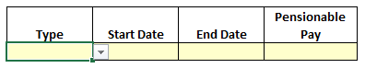

**Step 3**: enter the period of employment and pay for that post. GP locums must only enter actual working days that have been pensioned via 2023/24 locum forms.

**Step 4**: click on ‘add row’ and repeat the above steps for any other employments.

**Step 5**: when all employments for the year have been entered, click ‘calculate’. The calculator will display the annualised pay and the employee tiered contribution rate applicable.

**Step 6**: apply the same tiered employee contribution rate to all actual GP pensionable income when completing the annual certificate / self-assessment form.

**Step 7**: if a copy of the results is required, click on the ‘Print’ button.

**Step 8**: the form must be cleared before beginning any new or revised calculation.

### Examples:

1. **Type 1 GP post only**

From 1 June 2023 to 31 March 2024

Pensionable Profit = £60,000.00

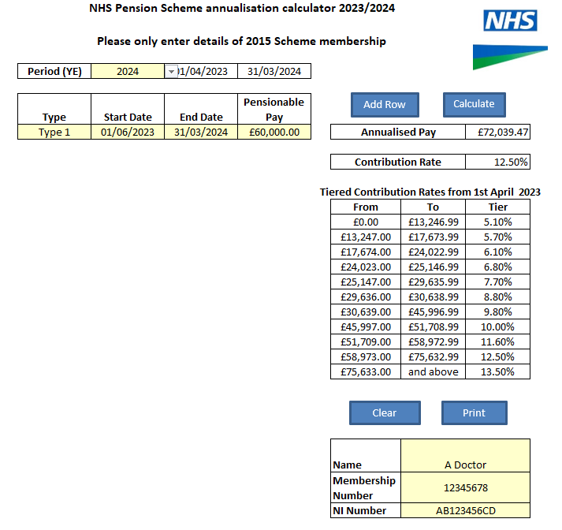

Annualised pay = £72,039.47  
Tiered contribution rate = 12.50 %

1. **Type 2 post only**

From 1 July 2023 to 28 February 2024

Actual pensionable pay for 1 July 2023 to 28 February 2024 = £42,500.00

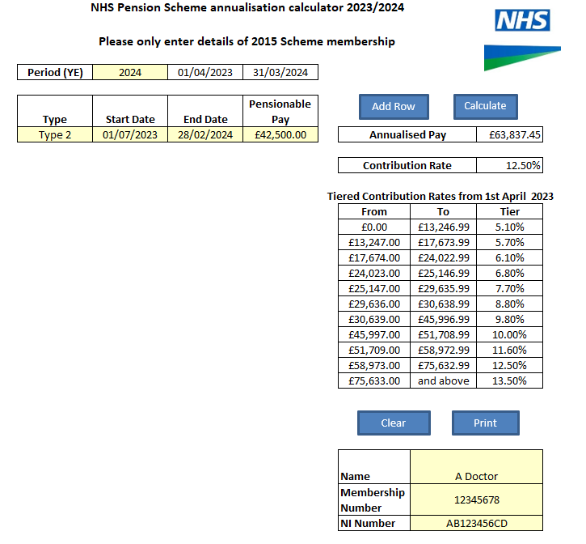

Annualised pay = £63,837.45  
Tiered contribution rate = 12.50 %

1. **Type 2 and GP locum**

Type 2: From 1 April 2023 to 31 October 2023

Actual pensionable = £32,000.00

GP Locum: From 7 June 2023 to 10 June 2023

Actual Pensionable Pay = £1,500.00

From 22 November 2023 to 24 November 2023

Actual pensionable pay = £1,050.00

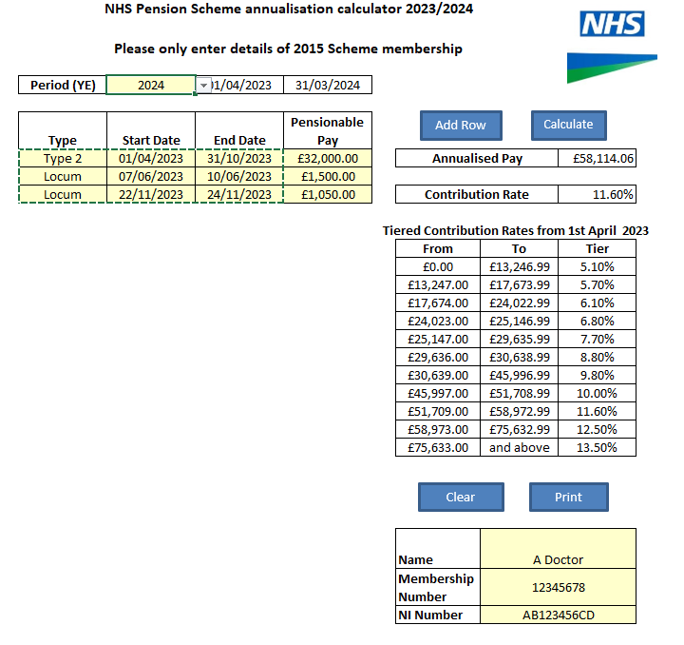

Annualised pay = £58,114.06  
Tiered contribution rate = 11.60 %

1. **Multiple posts: Type 2, locum and Type 1**

Type 2: From 1 April 2023 to 31 May 2023

Actual pensionable pay = £9,500.00

Locum: From 13 June 2023 to 17 June 2023

Actual pensionable pay = £2,250.00

Type 1: From 1 July 2023 to 31 March 2024

Pensionable Profit = £77,000.00

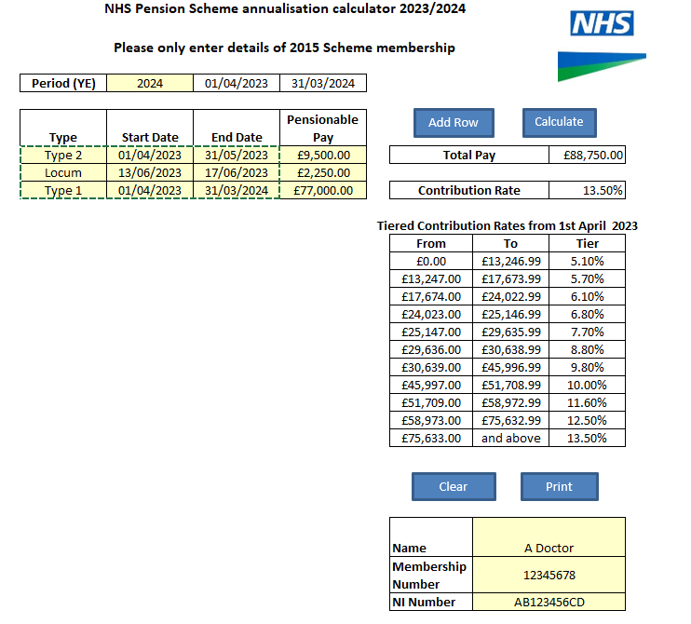

Annualised pay = £88,750.00  
Tiered contribution rate = 13.50 %

## Troubleshooting

The calculator does not work if it is run directly from within a browser, due to the macro’s it has within. If you save the file to your local drive this should resolve the ‘Enable Editing’ issue you see when you next open it.

The macro warning message will always appear if you are using the standard excel settings. It is advised that the default macro-option is not changed.

Once open in Excel, the Annualisation calculator produces the standard security warning that the macro’s have been disabled:

***Image showing a security warning that may appear ***

This is a default option that is set to avoid any macros running that the user may not want.

Click on the ‘Enable Content’ button to add the downloaded file to your trusted document list. Once the content is enabled, this should not be asked for again. However, this option may be subject to any locally set parameters by an IT departments’ policy settings, which they may set to actively block content.

**How we use your information**

For more information about how the NHSBSA processes your personal data, please see our Privacy Notice - [www.nhsbsa.nhs.uk/our-policies/privacy/nhs-pensions-privacy-notice](http://www.nhsbsa.nhs.uk/our-policies/privacy/nhs-pensions-privacy-notice)

**NHS Pensions**

**2023/24 Annualisation Calculator Guidance**

[www.nhsbsa.nhs.uk/nhs-pensions](http://www.nhsbsa.nhs.uk/nhs-pensions)

NHS Pensions, PO Box 683, Unit 5, Newcastle Upon Tyne, NE5 9EE