### Who we are and what we do

## Our purpose and vision

The NHS Business Services Authority is an Arm’s Length Body of the Department of Health and Social Care. We manage around £100 billion of NHS spend annually, delivering a range of national services to NHS organisations, NHS contractors, patients, and the public.

Our purpose is to deliver business service excellence to the NHS to help people live longer, healthier lives. Our vision is to be the provider of national, at scale business services for the health and social care system, transforming and delivering these services to maximise efficiency and meet customer expectations.

## Our customers

We put the customer at the centre of everything we do and we have segmented them into four groups.

|  |  |
| --- | --- |
| **Sponsors** | we are accountable to the DHSC |
| **Commissioners** | anyone who commissions a service from us for example NHS England or the Scottish and Welsh Assemblies |
| **Users** | anyone who uses our services, from a member of the public to clinical providers |
| **Colleagues** | our internal NHSBSA colleagues |

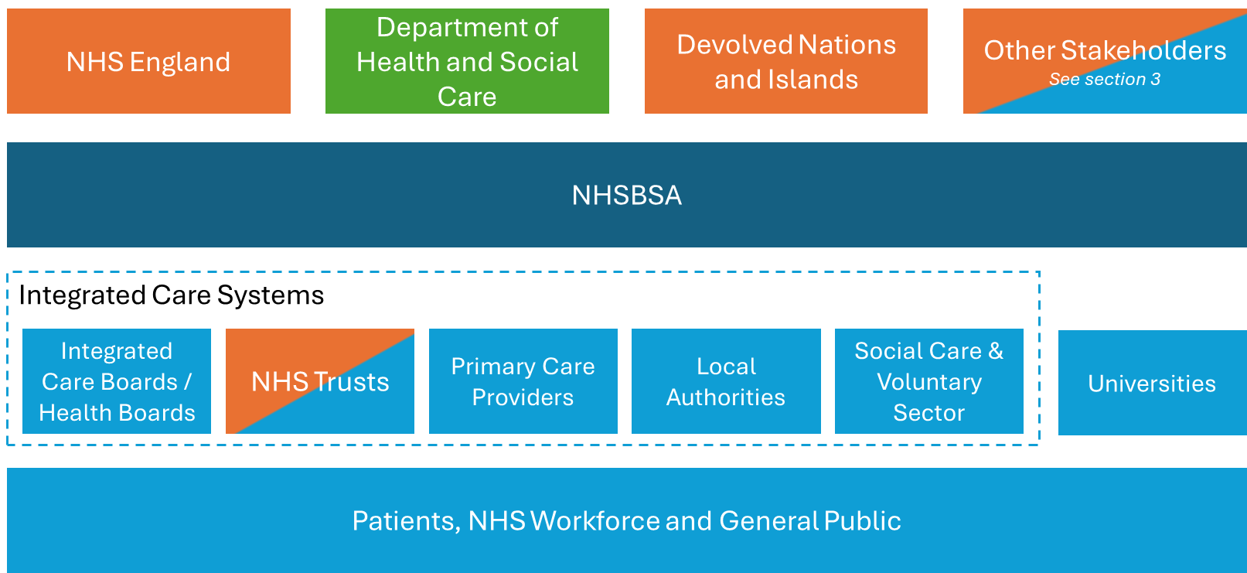

## Our stakeholders

Collaborating with external stakeholders is essential to ensure our success. They inform our decision-making through insight and help us manage risk. Working closely with our partners is vital to benefit the health and social care system as a whole.

* Department of Health & Social Care
* NHS England
* Department for Work & Pensions
* NHS Health Research Authority
* NHS Resolution
* NHS Professionals
* Social care
* NHS Regions
* Integrated Care Boards
* Integrated Care Partnerships
* Healthcare providers
* NHS Blood and Transplant
* National Institute for Health and Care Excellence
* Health Innovation Network
* Local Authorities
* NHS Shared Business Services
* Health Services Safety Investigations Body
* Human Fertilisation & Embryology Authority
* Professional and Representative Bodies
* VCSE Sector
* Department for Education
* Third Party Suppliers
* Medicines and Healthcare products Regulatory Agency
* Care Quality Commission
* NHS Counter Fraud Authority
* UK Health Security Agency
* Home Office
* Human Tissue Authority
* NHS Wales
* Office for Health Improvement & Disparities
* Directorate of Science Research and Evidence
* National Institute for Health and Care Research
* NHS Resolution