Guidance on the Hormone Replacement Therapy prescription prepayment certificate

Handling NHS HRT prescriptions

Published [XX August 2023]

Contents

1. Background 4

2. Changes 5

3. Hormone Replacement Therapy prescription prepayment certificate (HRT PPC) 7

What is HRT? 7

Scope (HRT covered by this change) 7

Cost of HRT 8

4. NHS prescription forms 9

Prescription form exemption page 9

Prescription form information page 10

5. Prescribers 11

Issuing prescriptions 11

HRT pathway 12

6. Dispensers 14

Changes to dispensing systems 14

Real Time Exemption Checking (RTEC) 15

Processing prescriptions 15

Mixed prescriptions 18

Selling HRT PPCs 21

FP57 Receipt and Refund form 21

7. Publications 23

Annex A - HRT medicines list 24

Annex B - New Paper Prescription Form 26

Annex C – Current Paper Prescription Form 27

Annex D - FP57 Receipt and Refund form 28

Annex E - HRT PPC flowchart 29

1. Background
   1. This document provides guidance to GPs, prescribers, pharmacists and pharmacy staff on new procedures which have been developed following the introduction of the Hormone Replacement Therapy prescription prepayment certificate (HRT PPC) which will exempt holders from prescription charges for applicable HRT treatment. The HRT PPC applies to England only.
   2. Ministers announced that they will reduce the cost of HRT for those patients who are not already exempt from prescription charges by introducing an annual prescription prepayment certificate for HRT, the HRT PPC. This certificate will allow individuals to access all the applicable licenced HRT treatments they need in a year for the cost of two single prescription items which is £19.30 from 1 April 2023. The HRT PPC is due to be implemented from 1 April 2023.
   3. The 3-month and 12-month PPC allow the patient to get as many NHS prescriptions as they need for a set price during the period of validity and include all prescription items. The HRT PPC, unlike the 3 or 12-month PPC, will exempt patients who hold it from charges for a subset of medicines, but they will still pay prescription charges for all other medicines. As this is a fundamentally different approach, there are steps that must be taken before we can achieve it and procedures and systems are being updated as quickly as possible.
   4. Regulations[1] have been amended to provide for exemption from prescription charges for those patients who hold a valid HRT PPC and the medicine supplied on an NHS prescription is for an item included on the HRT medicines list. This list of applicable items, the ‘HRT medicines list’, will be published in the NHS Drug Tariff Part XVI from April 2023. A provisional copy is included at Annex A for illustrative purposes, the online version should be accessed via the Drug Tariff to see the most up to date list.
2. Changes
   1. The main policy intention for the HRT PPC is to reduce the costs of HRT prescriptions for patients receiving HRT for the treatment of menopause symptoms, with one or more of the eligible HRT medicines. Patients who are receiving the eligible HRT medicines for other reasons may also purchase and benefit from the HRT PPC. To support this several changes are required.
   2. Regulations have been amended to mandate single item prescribing for the HRT medicines listed in the Drug Tariff and a discretion for dispensing contractors to refuse to dispense where mixed prescriptions, i.e. those containing eligible HRT and other medicines, are issued. This is important in ensuring, where possible, correct patient charging at the point of dispensing and pharmacy reimbursement and recovery of charges processes following the dispensing of the HRT item against the HRT PPC.
   3. The suite of FP10 prescription forms, including the FP10DT (EPS token) is being updated to include a new exemption tick box for patients who hold a valid HRT PPC. Minor changes have also been made to the patient information sheet.
   4. The main changes to the FP10 are as follows:
      1. A new exemption box W for patients who hold a valid HRT PPC
      2. Revised patient information page directing patients where to find information on reporting suspected side effects to medicines and medical device incidents to the MHRA Yellow Card scheme: [mhra.gov.uk/yellowcard](https://healthsharedservice-my.sharepoint.com/personal/stefan_politowicz_dhsc_gov_uk/Documents/Documents/mhra.gov.uk/yellowcard)
   5. A copy of the back of the new paper FP10 is provided at Annex B, a copy of the back of the current paper FP10 is provided at Annex C. The front of the prescription form has not changed.
   6. The updated suite of FP10s, and corresponding hospital outpatient prescription forms, will be put into circulation as soon as possible. There will be a period of transition where old stock is used up, prior to use of new stock; old stock should continue to be used until stocks of it run out. The NHS Business Services Authority (NHSBSA), which processes prescription forms for both the purposes of reimbursing pharmacies and carrying out exemption checking, will handle both old and new prescription forms during the transition. The new paper FP10 will be in circulation from the beginning of April 2023.
   7. The changes required to process the new HRT PPC have been made to NHSBSA systems. Changes are also being made to prescribing and dispensing systems.
3. Hormone Replacement Therapy prescription prepayment certificate (HRT PPC)

## What is HRT?

* 1. Oestrogen and progesterone are female hormones that play important roles in a woman’s body. Falling levels as a result of menopause or perimenopause cause a range of physical and emotional symptoms, including hot flushes, mood swings and vaginal dryness. Hormone Replacement Therapy (HRT) is a commonly prescribed treatment used to relieve symptoms of the menopause.
  2. In therapies for transgender people, HRT is used to increase the hormone levels associated with the gender with which the individual identifies. Some HRT medicines may also be prescribed for other purposes e.g. cancer treatments.

## Scope (HRT covered by this change)

* 1. An HRT PPC can only be used for treatment supplied on an NHS prescription form (FP10) where the item prescribed is included on the HRT medicines list published in the Drug Tariff (Part XVI).
  2. To be included on the HRT medicines list, the medicine must be HRT and must be licensed for treatment of menopause in the UK. The definition for inclusion and the full list of products can be found in Part XVI of the Drug Tariff <https://www.nhsbsa.nhs.uk/pharmacies-gp-practices-and-appliance-contractors/drug-tariff>.
  3. The HRT PPC will be valid for any product on the HRT medicines list, whatever the clinical reason for the prescription.
  4. The HRT medicines list has been compiled following consultation with the Medicines and Healthcare products Regulatory Agency (MHRA), NHSBSA and the NHS England Menopause Clinical Reference Group and will be updated as new products are licenced in the UK and products come to, and are removed from, the UK market.
  5. The HRT PPC cannot be used to provide exemption from charges for any item not included on the HRT medicines list, even if the medicine is often used to treat the symptoms of menopause e.g. antidepressants. HRT that is not licenced for use in the UK is also not in the scope of the HRT PPC e.g. testosterone.
  6. The HRT medicines list will be published in the Drug Tariff in Part XVI <https://www.nhsbsa.nhs.uk/pharmacies-gp-practices-and-appliance-contractors/drug-tariff> and on the HRT PPC information and application pages of the NHSBSA website [www.nhsbsa.nhs.uk/hrt-ppc](http://www.nhsbsa.nhs.uk/hrt-ppc).
  7. Prescription charges are not payable for medicines used for contraceptive purposes and certain contraceptive appliances when prescribed on NHS prescription forms. This applies no matter the purpose for which the contraceptive is prescribed. Where these contraceptives are used as the progestogenic opposition of oestrogen for HRT, prescription charges should not be levied. An example of this is the contraceptive IUS Mirena, which is also licensed for heavy bleeding and as HRT treatment for menopause. A patient should not apply for the HRT PPC to cover only these items.

## Cost of HRT

* 1. The National Health Services (Charges for Drugs and Appliances) Regulations 2015, as amended, provide for a charge to be applied ‘per quantity’ of medicine. As with other indications, treatment for the symptoms of the menopause may need more than one medicine.
  2. It is not uncommon for a course of HRT treatment to require the use of two or more medicines, usually oestrogen and progestogen. Manufacturers often supply the separate medicines in a single ‘combination pack’ to help patients take their medicine at the appropriate time. This means that when a pack contains more than one medicine or presentation, a prescription charge must be paid for each. Therefore, a dispensing pharmacist would need to apply one charge (set at £9.65 from 1 April 2023) for each medicine supplied, making a total charge of £19.30 for HRT treatments that include two hormone replacement medicines.
  3. The HRT PPC aims to reduce the cost of HRT by capping the cost annually at two times the single prescription charge.

1. NHS prescription forms

## Prescription form exemption page

* 1. An image of the reverse of the new NHS prescription form (FP10) can be seen in Annex B. The front of the form remains unchanged. The new suite of FP10s will have the version number 0522 e.g. FP10DT0522
  2. Patients who hold a valid HRT PPC and whose prescription item is one of those included in the HRT medicines list should select box W, HRT only prescription prepayment certificate on the new FP10/FP10DT (token).
  3. An image of the reverse of the current NHS prescription form can be seen in Annex C. The current suite of FP10 forms have the version number 1219 e.g. FP10DT1219.
  4. During the period of transition to the new prescription form a temporary workaround will be in place. If a patient holds a valid HRT PPC and the item prescribed is one of those included in the HRT medicines list, the patient should select box F prescription prepayment certificate on the current FP10/FP10DT (token). Procedures will be in place at NHSBSA to prevent patients using this workaround from receiving penalty charges unnecessarily.
  5. Selecting box F (prescription prepayment certificate) must only be used when all the items on the prescription are for listed HRT only, NOT for a mixed charge prescription (one that has both items from the HRT medicines list and non-listed HRT items). From 1 April all listed HRT items should be prescribed as single-item prescriptions (i.e. separate from all other prescription items, including other listed HRT items).
  6. Where a patient holds a valid HRT PPC and presents a mixed prescription it should be returned to the prescriber so that separate prescriptions can be issued. HRT and chargeable items cannot be dispensed from a single prescription where the patient is claiming exemption from charges because they hold a valid HRT PPC.
  7. Pharmacists may, at their discretion, dispense urgent items on the mixed prescription. If the non-HRT items are urgent, the appropriate charge should be levied. If the HRT items are urgent, these can be dispensed free of charge against a valid HRT PPC. Items not supplied should be marked 'not dispensed' or 'ND'. The patient should then request new prescriptions for any items not dispensed and complete the exemption page of the prescription form / token accordingly. If all items are required urgently the only option is for a patient to pay for all items and claim a refund using the supplied FP57 Receipt and Refund form.

1. Where the new exemption category W HRT only prescription prepayment certificate is NOT available and the patient holds a valid HRT PPC, the workaround, selecting box F prescription prepayment certificate, MUST only be used for prescriptions containing ONLY items from the HRT medicines list.

## Prescription form information page

* 1. Where included, the information sheet of the prescription form has been updated to notify patients that the HRT PPC is available and may save them money.
  2. Except for the FP10MDA (due to the size of the form and legal requirements) information has also been included to direct patients to the MHRA Yellow Card scheme, through which patients can report suspected side effects to medicines, vaccines, e-cigarettes, medical device incidents, defective or falsified (fake) products to the MHRA to ensure safe and effective use.

1. Prescribers
   1. This guidance outlines the regulatory requirements to support prescribing teams to issue prescriptions that can be correctly processed by dispensers to support the patients journey to access HRT medicines at a reduced cost. The Department recognises that upon launch, the HRT PPC will require some workarounds for prescribers until the digital solution to automatically separate prescriptions is in place. We will continue to work with the sector and system suppliers while we seek to introduce an appropriate digital solution as soon as possible.

## Issuing prescriptions

* 1. To reduce prescription costs for women receiving Hormone Replacement Therapy (HRT), on 1 April the Government will launch the HRT Prepayment Certificate (PPC).
  2. The HRT PPC will mean women will be able to pay a one-off charge equivalent to two single prescription charges, from 1 April this will cost £19.30 for all their HRT prescriptions for a year. The HRT PPC will negate the need for prescribers to issue longer prescriptions where the aim of this had previously been to reduce the costs of the HRT for the patient. Patients can continue on their usual cycle of prescriptions (for example monthly or 3-monthly), prescribers do not need to issue longer prescriptions. Information for patients who wish to obtain the HRT PPC can be found at [www.nhsbsa.nhs.uk/hrt-ppc](http://www.nhsbsa.nhs.uk/hrt-ppc).
  3. To enable the introduction of the HRT PPC, regulations have been amended to mandate that HRT medicines included on the HRT medicines list (published in the Drug Tariff in Part XVI at <https://www.nhsbsa.nhs.uk/pharmacies-gp-practices-and-appliance-contractors/drug-tariff>) must be provided on a separate NHS prescription from other prescription items from 1 April, this includes both paper and electronic forms and applies to all products on the HRT medicines list regardless of the clinical reason they are prescribed.
  4. A digital solution will be introduced as soon as possible to automate the issuing of listed HRT items as single-item prescriptions at the point of prescribing.
  5. In the meantime, prescribers will be required from 1 April to manually issue (e.g. via EPS) prescriptions for all listed HRT items as single-item prescriptions (i.e. separate from all other prescription items, including other listed HRT items). This is because NHSBSA and dispensing systems are not designed to handle mixed charge prescriptions; a patient either pays for all items on the prescription or they are exempt from charging. Unlike for free-of-charge items (contraceptives and STI treatment), there is no way to accurately process mixed charge prescriptions at the point of dispensing or at NHSBSA.
  6. Prescribers must issue listed HRT items as single-item prescriptions regardless of whether the patient has an HRT PPC at the time of prescribing. This is because an HRT PPC can be purchased by a patient at any point from either a pharmacy or the NHSBSA and can be backdated by up to one month from application. The separating of listed HRT items on a single prescription also applies to repeat prescriptions if the patient has other (non-HRT) medicines.
  7. If a prescriber issues a mixed prescription in error (i.e. one that includes both listed HRT medicines and other medicines), they will need to issue to the patient new single-item prescriptions for any listed HRT items, alongside a separate prescription for the other items.
  8. If a patient takes a mixed prescription to a dispenser, they will likely need to return to the prescriber to issue separate prescriptions for listed HRT items, having been unable to fill their prescription at the pharmacy. Pharmacy teams have various options as detailed in Section 6, which may require selected items to be reissued on a separate prescription. The appropriate option should be a joint decision shared with the patient and the pharmacy team to not impede access to critical medication and to ensure prescriptions can be correctly processed by the pharmacy.

## HRT pathway

* 1. HRT may be prescribed for indications other than the symptoms of menopause and the type of HRT prescribed is based on several factors: patient choice, patient adherence, safety and efficacy, and the use of NICE guidelines to inform clinical decision making.
  2. Regardless of why the HRT is prescribed, as part of the prescriber's discussion with the patient, the prescriber should, if time allows, make the patient aware of the availability of the HRT PPC, including which prescribed items are included on the HRT medicines list.
  3. The HRT PPC can be purchased at any time from 1 April 2023 and can be back dated for up to one month – a patient who is being prescribed HRT for the first time is not likely to hold an HRT PPC. Patients who are changing regime for example may have already purchased the HRT PPC.
  4. A patient currently in receipt of an electronic repeat dispensing (eRD) prescription can continue to obtain their HRT items and make an informed choice around costing to ensure best value for money for their individual circumstances.

1. Dispensers
   1. The Department recognises that upon launch, the HRT PPC will require some workarounds for pharmacy contractors (including other dispensary staff) and that there will be associated costs until solutions are in place. For example, workarounds for mixed prescriptions issued in error in the absence of a digital solution to automate the process. This guidance outlines the options for pharmacy contractors in different scenarios and the workarounds that have been put in place. We will continue to work with the sector seeking to mitigate and minimise the impact on pharmacy teams.

## Changes to dispensing systems

* 1. Dispensing system suppliers are updating dispensing systems to include the new HRT PPC exemption category. The HRT PPC exemption has been assigned box W and Electronic Reimbursement Message (EREM) code 0020.
  2. Where dispensing systems have not been updated a temporary workaround will be in place whereby letter F, EREM code 0007 prescription prepayment certificate should be selected.

See diagrams below illustrating EREM codes for HRT PPC

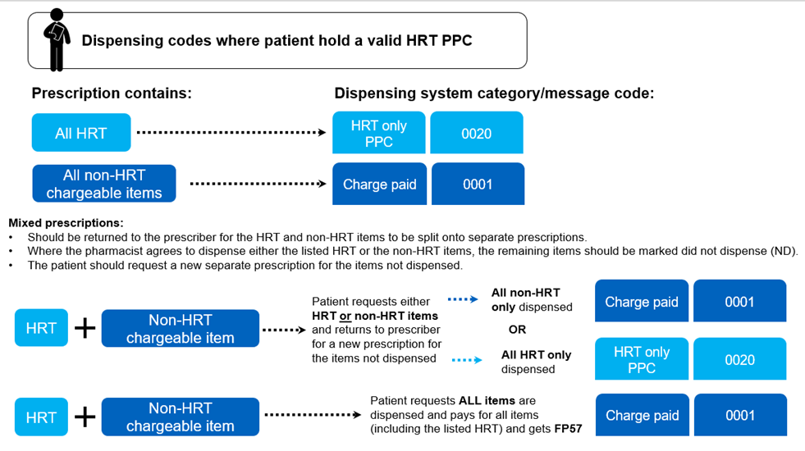

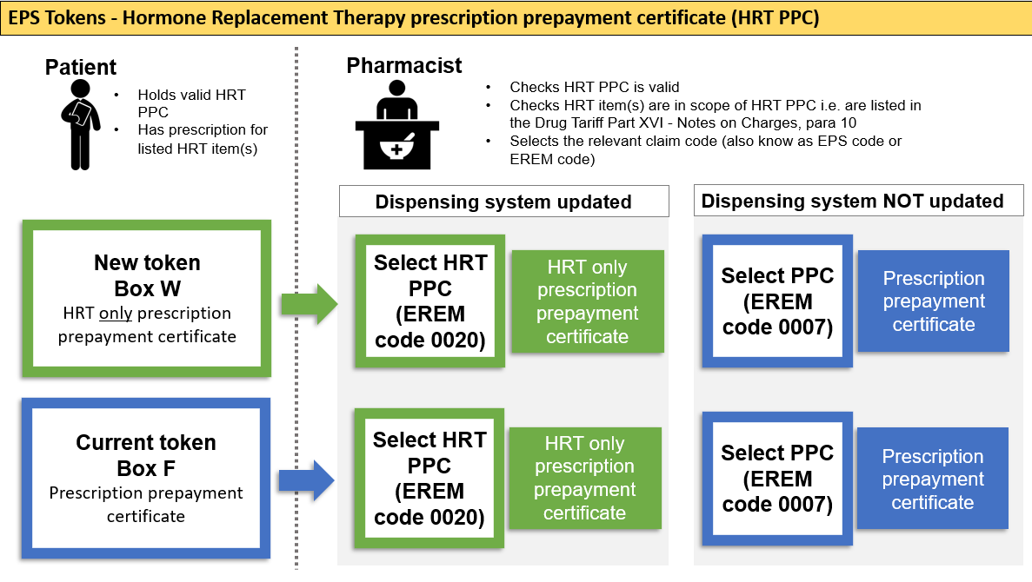

## Real Time Exemption Checking (RTEC)

* 1. Currently, due to the complexities of checking for exemption against specific medicines, RTEC is not available for confirming whether a patient has a valid HRT PPC. Changes to RTEC will be made as soon as possible.

## Processing prescriptions

* 1. Regulations have been amended so that dispensing contractors will be able to, but not be required to, refuse to supply items on a mixed prescription where a charge exemption is being claimed based on the HRT PPC (see para 6.7 mixed prescriptions).

##### Does not hold a valid HRT PPC

* 1. Where a patient does not hold a valid HRT PPC, the prescription should be processed in the usual way. If the patient intends to buy the HRT PPC, they should be provided with a FP57 Receipt and Refund form. The patient will either:

pay for all items and the prescription will be processed as charge paid (except where an item is free-of-charge (i.e. contraceptives and STI treatment) or

be exempt from charges and the prescription will be processed accordingly.

##### For prescriptions that ONLY contain items on the HRT medicines list and the patient holds a valid HRT PPC, no charge will be levied.

##### New FP10 prescription form:

The patient:

should be instructed to select box W, HRT only prescription prepayment certificate on the new FP10

should provide evidence that they hold a valid HRT PPC

The dispenser:

should check evidence of a valid HRT PPC

should confirm the items for which the HRT PPC is being used are on the HRT medicines list

place paper form in exempt bundle

##### New tokens

The patient:

should be instructed to select box W, HRT only prescription prepayment certificate on the new token

provide evidence that they hold a valid HRT PPC

The dispenser

should check evidence of a valid HRT PPC

confirm the items for which the HRT PPC is being used are on the HRT medicines list

should select for the option for 'HRT only prescription prepayment certificate' (EREM 0020) on updated dispensing systems, or the option for 'prescription prepayment certificate' (EREM code 0007) where dispensing systems have not been updated

##### Current FP10 prescription form:

The patient:

should be instructed to select box F prescription prepayment certificate on the current FP10

should provide evidence that they hold a valid HRT PPC

The dispenser:

should check evidence of a valid HRT PPC

should confirm the items for which the HRT PPC is being used are on the HRT medicines list

Place paper prescriptions in the exempt bundle.

##### Current token

The patient

should be instructed to select box F prescription prepayment certificate on the current token and provide evidence that they hold a valid HRT PPC

The dispenser

should check evidence of a valid HRT PPC

confirm the items for which the HRT PPC is being used are on the HRT medicines list

should select EREM code 0020 on updated dispensing systems. If the dispensing system has not been updated EREM code 0007 should be selected.

1. Where the new exemption category W HRT only prescription prepayment certificate is NOT available and the patient holds a valid HRT PPC, the workaround, selecting box F prescription prepayment certificate, MUST only be used for prescriptions containing ONLY items from the HRT medicines list.

## Mixed prescriptions

* 1. Regulations mandate that items on the HRT medicine list should be issued on separate prescriptions from other prescription items. Mixed prescriptions are those that contain both items from the HRT medicines list and items not on the HRT medicines list, non-HRT.
  2. If a mixed prescription is issued in error and the patient does not hold a valid HRT PPC, prescription charges should be levied for all items as usual.
  3. If a mixed prescription is issued in error and the patient holds a valid HRT PPC the prescription should be returned to the prescriber so the items from the HRT medicines list can be re-issued on a separate prescription.
  4. So as not to cut across a pharmacist's discretion to dispense urgently needed medicines, a pharmacist may dispense either the listed HRT or the non-HRT items on a mixed prescription. Items not dispensed should be marked as not dispensed and the prescriber should be asked to re-issue a prescription for the items not dispensed.
  5. If the patient holds a valid HRT PPC and needs both the listed HRT and non-HRT medicines urgently, and returning the prescription to the prescriber to have the items separated is not possible, the only option available that will allow both the HRT and non-HRT to be dispensed is for the patient to agree to pay the charge for each item and claim a refund for the items covered by their valid HRT PPC using the FP57 Receipt and Refund form.

##### If the non-HRT items only are dispensed:

The patient:

Pays the applicable prescription charges

Completes the FP10/token to confirm they have paid the charges levied.

Asks prescriber to issue a new script for the items that were not dispensed - with the items on the HRT medicines list on a separate prescription from any non-HRT

The dispenser:

Marks the HRT items not dispensed (ND)

Collects the appropriate charge for the non-HRT items that are dispensed and processes FP10/token as charge paid

Instructs patient to ask the prescriber for a new prescription for the items that have not been dispensed, with items on the HRT medicines list on separate prescriptions

##### If the listed HRT items only are dispensed:

The patient:

Shows evidence of their valid HRT PPC and completes the FP10/token to confirm they are exempt from charges for the listed HRT

Asks prescriber to issue a new script for the items that were not dispensed

The dispenser:

Checks evidence of valid HRT PPC, or if not available, selects 'evidence not seen'

Dispenses the listed HRT items and marks the other items not dispensed (ND)

Instructs patient to ask the prescriber for a new prescription for the items that have not been dispensed

##### Patient has a valid HRT PPC and urgently needs all items on the mixed prescription

Patient

Agrees to pay the charge for all items and completes FP10/token to confirm they have paid the charges levied

Collects FP57 Receipt and Refund form

Note: this would also apply if a patient did not have evidence of their HRT PPC exemption at the time they collected their prescription and would be expected to pay the charge.

Dispenser

Dispenses all items (HRT and non-HRT) and collects the appropriate charge for all items

Provides patient with FP57 Receipt and Refund form

1. For a mixed charge prescription where the patient holds a valid HRT PPC the options are:
2. 1 - No items dispensed - return prescription to prescriber for items to be separated.
3. 2 - Urgent items dispensed - patient and pharmacist agree which items (all HRT or all non-HRT) are dispensed. Patient is referred back to the prescriber to obtain a separate prescription for the item(s) not dispensed.
4. 3 - All items urgent and dispensed - patient pays for all items and gets a FP57 Receipt and Refund form

Diagram illustrating the options available for handling a mixed prescription. See also flow chart at Annex E.

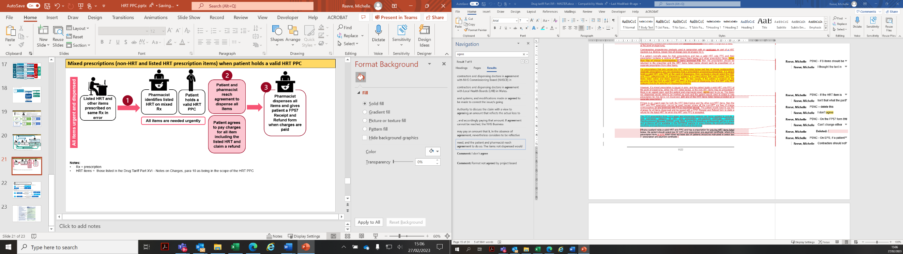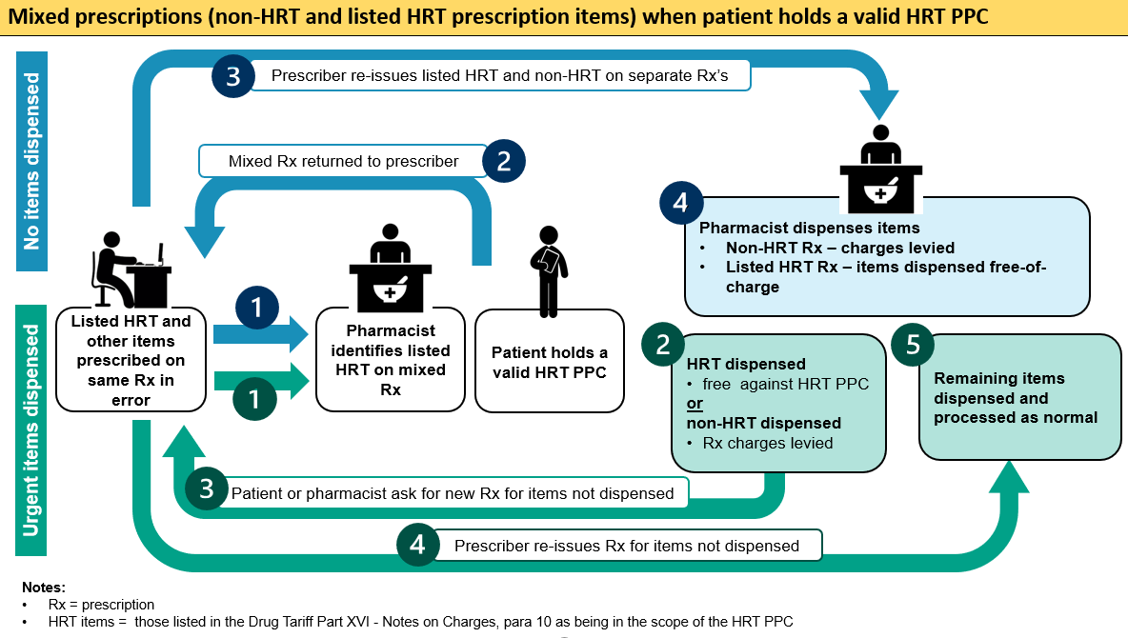

## Selling HRT PPCs

* 1. The HRT PPC could save a patient money if:

they pay for their NHS prescriptions

do not already have a valid 3 or 12-month PPC that covers all their NHS prescriptions (including HRT) for a set price

require three or more items from the HRT medicines list in 12 months

* 1. HRT PPCs sold in pharmacy from 1 April 2023 can be processed through [Manage Your Service (MYS)](https://services.nhsbsa.nhs.uk/nhs-prescription-services-submissions/login). Information on selling HRT PPCs will be available on the NHSBSA website at [www.nhsbsa.nhs.uk/pharmacysales](http://www.nhsbsa.nhs.uk/pharmacysales).

## FP57 Receipt and Refund form

* 1. The FP57 is the NHS prescription charge receipt and refund claim form that is issued in England. They should be issued when someone pays for their NHS prescriptions and either requires an NHS receipt or intends to claim a refund of charges paid: an FP57 cannot be obtained later. The patient has 3 months from the date the charge was paid to claim a refund for prescription charges. If more than 3 months have elapsed between the time the charge was paid and the prescription refund and receipt form is presented for payment, the refund may not be paid unless the patient has a form LIS04(P) from the NHSBSA.
  2. The FP57 has been updated to allow pharmacists to record the number of charges paid for items on the HRT medicines list separately from other prescription items, and to address some outstanding required amendments e.g. Universal Credit and naming of the war pension exemption. Old stock should continue to be used until it runs out, but new stock can be used once available if the refund is for items on the HRT medicines list.
  3. Pharmacists are not required to record the name of the medicines or appliances dispensed on the FP57 Receipt and Refund form, only the rate / number of charges paid. The pharmacist that issues the FP57 and collects the charge may not necessarily be the same pharmacist that processes the patients refund claim; therefore Part A (now Part 1) of the new FP57 form has been updated with an additional row to allow pharmacist to record the number of charges for items on the HRT medicines list (see Annex D). This allows the pharmacists processing the claim to confirm that a patient claiming a refund because they had a valid HRT PPC on the date the charges were paid are doing so against applicable medicines only i.e. those on the HRT medicines list.
  4. If a patient plans to claim a refund for an HRT item on the grounds that they held a valid HRT only PPC that applied at the point of dispensing, or they were considering applying for a backdated HRT only PPC and the new FP57 is not available, the pharmacist should issue a separate ‘old’ FP57 for listed HRT items and non-HRT items, with the HRT items in Part A of the form annotated with ‘Listed HRT’ and initialled to confirm the charges paid were for listed HRT items.
  5. The HRT PPC can be backdated up to one month from the date of application (but not prior to 1 April 2023). A patient may also be waiting for a paper certificate to arrive at the time they need their HRT medicine. In these circumstances a patient may choose to pay the applicable charges for the listed HRT items and claim a refund later.
  6. Pharmacists must issue the patient with a FP57 Receipt and Refund form at the time the patient pays the charges if:

the patient (or representative) requests one for any reason.

the patient (or representative) is unsure whether they are entitled to free prescriptions; or

the patient (or representative) has applied or will be applying for a prescription charge exemption certificate or prepayment certificate (3-month PPC, 12-month PPC or HRT PPC).

1. Publications
   1. Communications packs and hints and tips for GPs, pharmacy contractors and patients are available at the following:

Toolkit for primary care providers to introduce a new HRT PPC: [www.nhsbsa.nhs.uk/hrt-ppc-guidance](http://www.nhsbsa.nhs.uk/hrt-ppc-guidance)

HRT PPC webpage for patients: [www.nhsbsa.nhs.uk/hrt-ppc](http://www.nhsbsa.nhs.uk/hrt-ppc), or [www.nhsbsa.nhs.uk/help-nhs-prescription-costs/nhs-hormone-replacement-therapy-prescription-prepayment-certificate-hrt-ppc](http://www.nhsbsa.nhs.uk/help-nhs-prescription-costs/nhs-hormone-replacement-therapy-prescription-prepayment-certificate-hrt-ppc)

HRT PPC medicines list: [www.nhsbsa.nhs.uk/hrt-ppc-medicines](http://www.nhsbsa.nhs.uk/hrt-ppc-medicines), or <https://www.nhsbsa.nhs.uk/help-nhs-prescription-costs/nhs-hormone-replacement-therapy-prescription-prepayment-certificate-hrt-ppc/medicines-covered-hrt-ppc>

The Drug Tariff (see Part XVI) is available at: <https://www.nhsbsa.nhs.uk/pharmacies-gp-practices-and-appliance-contractors/drug-tariff>

The National Health Service (Amendments Relating to Pre-Payment Certificates, Hormone Replacement Therapy Treatments and Medicines Shortages) Regulations 2023: <https://www.legislation.gov.uk/uksi/2023/171/contents/made>

# Annex A - Links

## Medicines List

The HRT medicines list is published in the Drug Tariff in Part XVI:

<https://www.nhsbsa.nhs.uk/pharmacies-gp-practices-and-appliance-contractors/drug-tariff>

and on the HRT PPC information and application pages of the NHSBSA website:

[www.nhsbsa.nhs.uk/hrt-ppc](http://www.nhsbsa.nhs.uk/hrt-ppc)

## Definition

The HRT definition can be found in the Drug Tariff in Part XVI:

<https://www.nhsbsa.nhs.uk/pharmacies-gp-practices-and-appliance-contractors/drug-tariff>

# Annex B - New Paper Prescription Form

Reverse (Front of form is unchanged)

1. 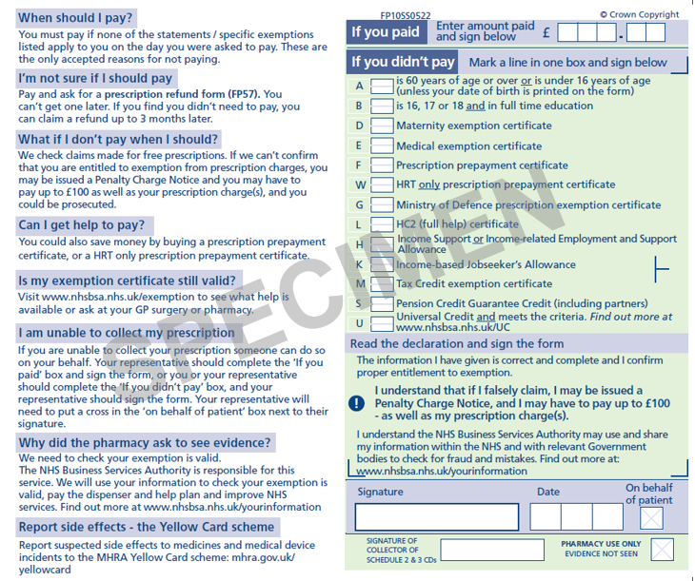

# Annex C – Current Paper Prescription Form

Reverse

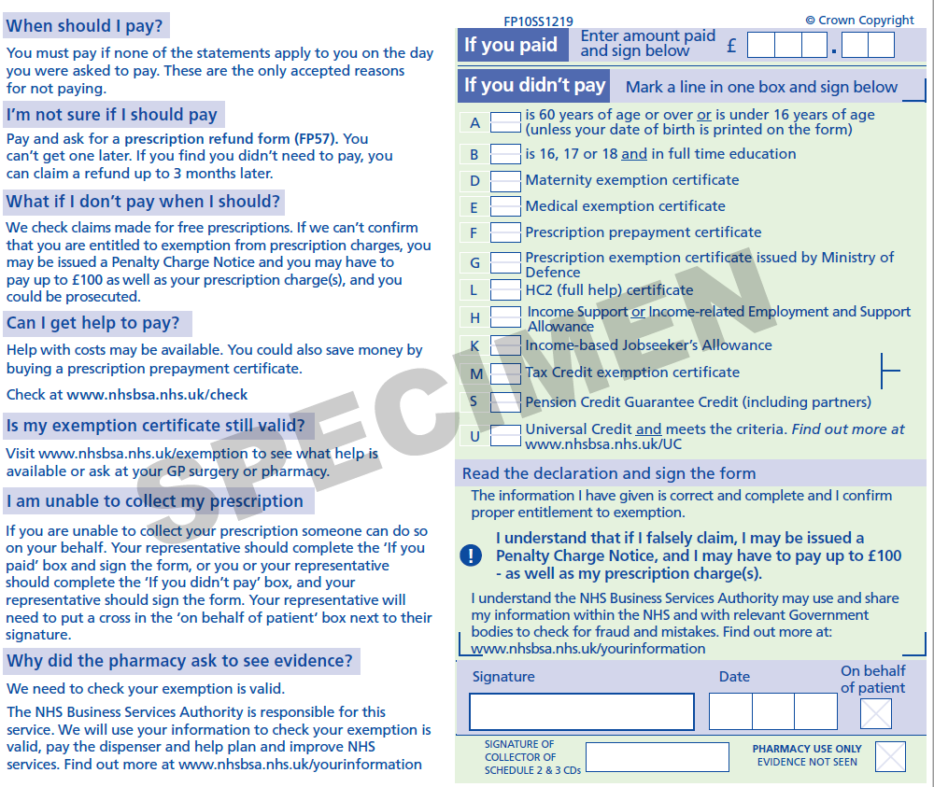

# Annex D - FP57 Receipt and Refund form

New form

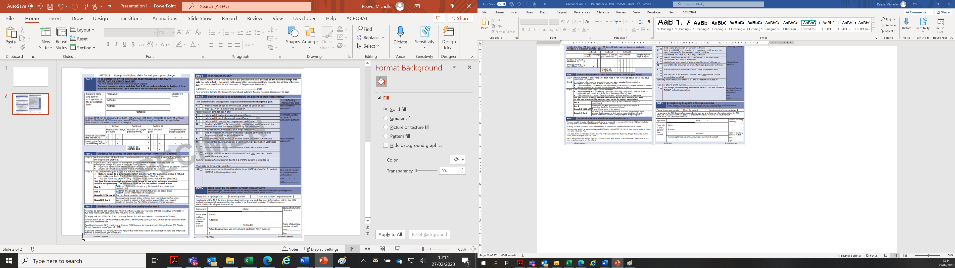

# Annex E - HRT PPC flowchart

The NHSBSA flowchart "Pharmacy NHS Prescription Prepayment Certificate (PPC) Process" referenced in the flowchart below can be found at [www.nhsbsa.nhs.uk/pharmacysales](https://eur03.safelinks.protection.outlook.com/?url=http%3A%2F%2Fwww.nhsbsa.nhs.uk%2Fpharmacysales&data=05%7C01%7Cmichelle.reeve%40dhsc.gov.uk%7C65358abc5a9e412d3bc008db26fa21fa%7C61278c3091a84c318c1fef4de8973a1c%7C1%7C0%7C638146628161269852%7CUnknown%7CTWFpbGZsb3d8eyJWIjoiMC4wLjAwMDAiLCJQIjoiV2luMzIiLCJBTiI6Ik1haWwiLCJXVCI6Mn0%3D%7C3000%7C%7C%7C&sdata=cdTfn8IT7mb7ojY9A1MqSPWScxgSFHyidykI5GSZVGA%3D&reserved=0).

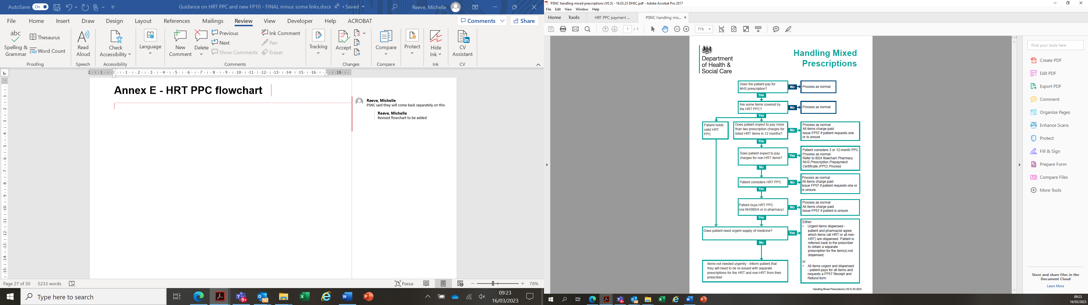

© Crown copyright 2023

[www.gov.uk/dhsc](https://www.gov.uk/dhsc)

This publication is licensed under the terms of the Open Government Licence v3.0 except where otherwise stated. To view this licence, visit [nationalarchives.gov.uk/doc/open-government-licence/version/3](http://nationalarchives.gov.uk/doc/open-government-licence/version/3/)

Where we have identified any third party copyright information you will need to obtain permission from the copyright holders concerned.



1. https://www.legislation.gov.uk/uksi/2023/171/contents/made