NHS Prescription Services
Bridge House
152 Pilgrim Street
Newcastle upon Tyne
NE1 6SN

0845 850 0001
nhsbsa.prescriptionservices@nhs.net
www.nhsbsa.nhs.uk

15 August 2022

VERSION 8.2.0

Dear dm+d User,

Advanced notice: Interesting Excipients authoring in dm+d to come to an end

Further to feedback from dm+d users on the recent ‘Interesting’ excipient consultation (18/04/22 – 17/06/22) the dm+d Content Committee chaired by DHSC have approved the decision to end the authoring of the interesting excipient information in dm+d.

The timetable and exact details of this change will be communicated in due course.

The following VMP SNOMED code changes have been made
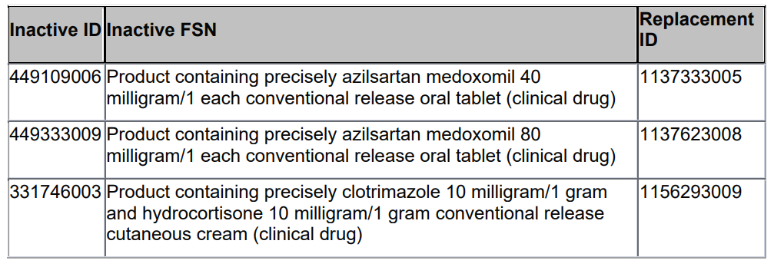
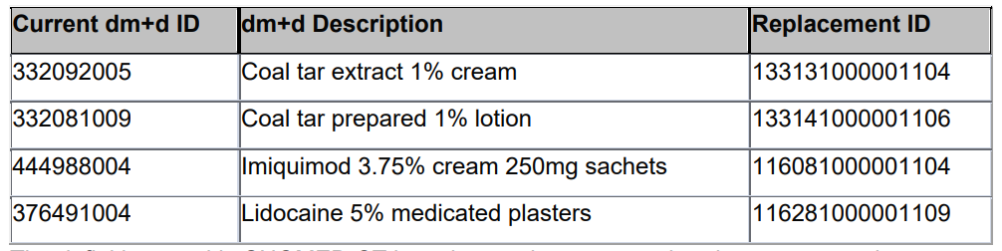

Workpackage to Support Advisory Committee on Borderline Substances (ACBS) dietician experts and Impacts on SNOMED codes

This is advanced notice that over the course of the next few months, in the region of 400 to 450 food substance AMPs will be invalidated and moved to different VMPs.
The NHSBSA is supporting an initiative by Advisory Committee on Borderline Substances (ACBS) dietician experts to improve the clinical categorisation / classification of food substances.
We are mindful that where new SNOMED codes are used that this can add challenges to EPS until prescribing and dispensing systems are aligned. We will therefore try to communicate changes as best we can but this will also need yourselves as dm+d users to please monitor this weekly communication and for system suppliers to please refresh and update your drug dictionary data with the most recent version of the dm+d files available.
More information will be communicated over the forthcoming weeks. In the meanwhile if you have any further questions, please email nhsbsa.dmdenquiries@nhs.net

DHSC require these concepts to be made available and visible (similar to licensed medicines) in prescribing and dispensing systems for the time being.

Specials/Imports added at request of DHSC to mitigate shortages in the supply chain
AMP Name | AMP SNOMED Code | Import/Special | dm+d extract date
Desmopressin 150micrograms/dose nasal spray | 38955011000001100 | Imported | 14/09/2020
Desmopressin 150micrograms/dose nasal spray | 38996011000001101 | Special Order | 21/09/2020
Cloral betaine 707mg tablets | 39069011000001104 | Imported | 12/10/2020
Gynokadin 0.06% gel | 40714711000001102 | Imported (Germany) | 13/06/2022
Oestraclin 0.06% gel | 40714911000001100 | Imported (Spain) | 13/06/2022
Sandrena 1mg gel sachets | 40715411000001109 | Imported (Italy) | 13/06/2022
Lenzetto 1.53mg/dose transdermal spray | 40715811000001106 | Imported (Poland) | 13/06/2022
Ovestin 1mg cream | 40716111000001105 | Imported (Germany) | 13/06/2022
Promethazine hydrochloride 25mg tablets | 40822911000001101 | Imported | 18/07/2022
Alendronic acid 70mg tablets | 40855711000001108 | Imported | 01/08/2022
Aripiprazole 10mg tablets | 40884711000001102 | Imported | 15/08/2022
Invalidations
None

Advance Notice of Invalidations
The following concept will be invalidated mid-Aug. The product was authored incorrectly and has been reauthored under a new VMP.

Concept to be made Invalid | Replacement concepts
VMP  N/A | VMP  Teicoplanin 200mg powder for solution for injection vials
VMP SNOMED ID  N/A | VMP SNOMED ID  766184003
VMPP  N/A | VMPP  1 vial
VMPP SNOMED ID  N/A | VMPP SNOMED ID  40739711000001109
AMP  Teicoplanin 200mg powder and solvent for solution for injection vials (Consilient Health Ltd) | AMP  Teicoplanin 200mg powder for solution for injection (Consilient Health Ltd)
AMP SNOMED ID  40541411000001101 | AMP SNOMED ID  40739811000001101
AMPP  1 Vial | AMPP  1 Vial
AMPP SNOMED ID  40541711000001107 | AMPP SNOMED ID  40740011000001100

The following concept will be invalidated in mid-Aug. The product was authored incorrectly
and has been reauthored under a new VMP.

Concept to be made Invalid | Replacement concepts
VMP  N/A | VMP  Teicoplanin 400mg powder for solution for injection vials
VMP SNOMED ID  N/A | VMP SNOMED ID  766185002
VMPP  N/A | VMPP  1 vial
VMPP SNOMED ID  N/A | VMPP SNOMED ID  40740511000001108
AMP  Teicoplanin 400mg powder and solvent for solution for injection vials (Consilient Health Ltd) | AMP  Teicoplanin 400mg powder for solution for injection (Consilient Health Ltd)
AMP SNOMED ID  40542711000001100 | AMP SNOMED ID  40740711000001103
AMPP  1 Vial | AMPP  1 Vial
AMPP SNOMED ID  40542811000001108 | AMPP SNOMED ID  40740811000001106

The following concept will be invalidated mid-Aug, due to a change of the AMPP pack size.

Concept to be made Invalid | Replacement concepts
AMP  Schollmed Once Weekly Fungal Nail Treatment 5% medicated nail lacquer (Scholl's Wellness Company Ltd) | AMP  (AMP not being invalidated)
AMP SNOMED ID  35749711000001104 | AMP SNOMED ID  N/A
AMPP  3ml | AMPP  2.5ml
AMPP SNOMED ID  35749811000001107 | AMPP SNOMED ID  40773611000001104

The following concept will be invalidated mid-Sept. The product was authored incorrectly and has been reauthored under a new VMP.

Concept to be made Invalid | Replacement concepts
VMP  N/A | VMP  Amsacrine 75mg/1.5ml concentrate and solvent for solution for infusion vials
VMP SNOMED ID  N/A | VMP SNOMED ID  40828911000001103
VMPP  N/A | VMPP  6 vial
VMPP SNOMED ID  N/A | VMPP SNOMED ID  40828611000001109
AMP  Amsidine 75mg/1.5ml solution for infusion ampoules and dilutent (Eurocept International bv) | AMP  Amsidine 75mg/1.5ml concentrate and solvent for solution for infusion vials (Eurocept International bv)
AMP SNOMED ID  24403811000001102 | AMP SNOMED ID  40828711000001100
AMPP  6 ampoule | AMPP  6 vial
AMPP SNOMED ID  24403911000001107 | AMPP SNOMED ID  40828811000001108

The following concepts will be invalidated mid-Sept. The packs have been reauthored under new AMPs.

Concept to be made Invalid | Replacement concepts
AMP  Dulcolax Adult 5mg gastro-resistant tablets (Sanofi)  (AMP not being invalidated) | AMP  Dulcolax Twelve Plus 5mg gastro-resistant tablets (Sanofi)
AMP SNOMED ID  N/A | AMP SNOMED ID  40845911000001107
AMPP  40 tablet  100 tablet | AMPP  40 tablet  100 tablet
AMPP SNOMED ID  13534711000001106  13534011000001109 | AMPP SNOMED ID  40846011000001104  40846111000001103

Concept to be made Invalid | Replacement concepts
AMP  Dulcolax Pico Adult 5mg/5ml liquid (Sanofi)  (AMP not being invalidated) | AMP  Dulcolax Pico Twelve Plus 5mg/5ml liquid (Sanofi)
AMP SNOMED ID  N/A | AMP SNOMED ID  40846211000001109
AMPP  300ml | AMPP  300ml
AMPP SNOMED ID  2489811000001109 | AMPP SNOMED ID  40846311000001101

dm+d Authoring Team

