|  |  |
| --- | --- |
|  | **NHS Prescription Services**  Bridge House  152 Pilgrim Street  Newcastle upon Tyne  NE1 6SN  0845 850 0001  nhsbsa.prescriptionservices@nhs.net  [www.nhsbsa.nhs.uk](http://www.nhsbsa.nhs.uk)  8 August 2022 |
|  |

VERSION 8.1.0

Dear dm+d User,

**Advanced notice: Xailin Hydrate 0.3% eye drops preservative free (Visufarma UK Ltd)**

Currently it is listed under the VMP of Hypromellose 0.3% eye drops preservative free. This was erroneously authored under this VMP and from 1st August in dm+d, we are going to re-author this under the VMP Hypromellose 0.3% eye drops. We will have processes in place to ensure that prescriptions submitted for payment will be reimbursed appropriately. Also to minimise inconvenience for users, technical support colleagues are going to effectively ‘lift and shift’ this concept in dm+d to keep codes and IDs the same (just a different VMP parent).

This update will be evident in the dm+d extract files on Monday 8th August.

Also regarding VMP trees that just have linking medical devices, in line with our understanding, we are aiming to update VMP prescribing statuses to ‘Caution - AMP level prescribing advised’

**The following VMP SNOMED code changes have been made**

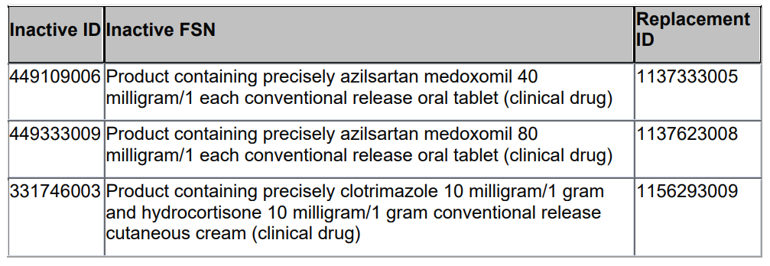

**Workpackage to Support Advisory Committee on Borderline Substances (ACBS) dietician experts and Impacts on SNOMED codes**

This is advanced notice that over the course of the next few months, in the region of 400 to 450 food substance AMPs will be invalidated and moved to different VMPs.

The NHSBSA is supporting an initiative by Advisory Committee on Borderline Substances (ACBS) dietician experts to improve the clinical categorisation / classification of food substances.

We are mindful that where new SNOMED codes are used that this can add challenges to EPS until prescribing and dispensing systems are aligned. We will therefore try to communicate changes as best we can but this will also need yourselves as dm+d users to please monitor this weekly communication and for system suppliers to please refresh and update your drug dictionary data with the most recent version of the dm+d files available.

More information will be communicated over the forthcoming weeks. In the meanwhile if you have any further questions, please email [nhsbsa.dmdenquiries@nhs.net](mailto:nhsbsa.dmdenquiries@nhs.net)

**DHSC require these concepts to be made available and visible (similar to licensed medicines) in prescribing and dispensing systems for the time being.**

|  |  |  |  |
| --- | --- | --- | --- |
| **Specials/Imports added at request of DHSC to mitigate shortages in the supply chain** | | | |
| **AMP Name** | **AMP SNOMED Code** | **Import/Special** | **dm+d extract date** |
| Desmopressin 150micrograms/dose nasal spray | 38955011000001100 | Imported | 14/09/2020 |
| Desmopressin 150micrograms/dose nasal spray | 38996011000001101 | Special Order | 21/09/2020 |
| Cloral betaine 707mg tablets | 39069011000001104 | Imported | 12/10/2020 |
| Gynokadin 0.06% gel | 40714711000001102 | Imported (Germany) | 13/06/2022 |
| Oestraclin 0.06% gel | 40714911000001100 | Imported (Spain) | 13/06/2022 |
| Sandrena 1mg gel sachets | 40715411000001109 | Imported (Italy) | 13/06/2022 |
| Lenzetto 1.53mg/dose transdermal spray | 40715811000001106 | Imported (Poland) | 13/06/2022 |
| Ovestin 1mg cream | 40716111000001105 | Imported (Germany) | 13/06/2022 |
| Promethazine hydrochloride 25mg tablets | 40822911000001101 | Imported | 18/07/2022 |
| Alendronic acid 70mg tablets | 40855711000001108 | Imported | 01/08/2022 |

**Invalidations**

None

**Advance Notice of Invalidations**

The following concept will be invalidated mid-Aug. The product was authored incorrectly and has been reauthored under a new VMP.

|  |  |
| --- | --- |
| **Concept to be made Invalid** | **Replacement concepts** |
| **VMP** N/A | **VMP**  Teicoplanin 200mg powder for solution for injection vials |
| **VMP SNOMED ID** N/A | **VMP SNOMED ID** 766184003 |
| **VMPP** N/A | **VMPP** 1 vial |
| **VMPP SNOMED ID** N/A | **VMPP SNOMED ID** 40739711000001109 |
| **AMP** Teicoplanin 200mg powder and solvent for solution for injection vials (Consilient Health Ltd) | **AMP** Teicoplanin 200mg powder for solution for injection(Consilient Health Ltd) |
| **AMP SNOMED ID** 40541411000001101 | **AMP SNOMED ID** 40739811000001101 |
| **AMPP** 1 Vial | **AMPP** 1 Vial |
| **AMPP SNOMED ID** 40541711000001107 | **AMPP SNOMED ID** 40740011000001100 |

The following concept will be invalidated in mid-Aug. The product was authored incorrectly

and has been reauthored under a new VMP.

|  |  |
| --- | --- |
| **Concept to be made Invalid** | **Replacement concepts** |
| **VMP** N/A | **VMP**  Teicoplanin 400mg powder for solution for injection vials |
| **VMP SNOMED ID** N/A | **VMP SNOMED ID** 766185002 |
| **VMPP** N/A | **VMPP** 1 vial |
| **VMPP SNOMED ID** N/A | **VMPP SNOMED ID** 40740511000001108 |
| **AMP** Teicoplanin 400mg powder and solvent for solution for injection vials (Consilient Health Ltd) | **AMP** Teicoplanin 400mg powder for solution for injection(Consilient Health Ltd) |
| **AMP SNOMED ID** 40542711000001100 | **AMP SNOMED ID** 40740711000001103 |
| **AMPP** 1 Vial | **AMPP** 1 Vial |
| **AMPP SNOMED ID** 40542811000001108 | **AMPP SNOMED ID** 40740811000001106 |

The following concept will be invalidated mid-Aug, due to a change of the AMPP pack size.

|  |  |
| --- | --- |
| **Concept to be made Invalid** | **Replacement concepts** |
| **AMP** Schollmed Once Weekly Fungal Nail Treatment 5% medicated nail lacquer **(**Scholl's Wellness Company Ltd) | **AMP** (AMP not being invalidated) |
| **AMP SNOMED ID** 35749711000001104 | **AMP SNOMED ID** N/A |
| **AMPP** 3ml | **AMPP** 2.5ml |
| **AMPP SNOMED ID** 35749811000001107 | **AMPP SNOMED ID** 40773611000001104 |

The following concept will be invalidated mid-Sept. The product was authored incorrectly and has been reauthored under a new VMP.

|  |  |
| --- | --- |
| **Concept to be made Invalid** | **Replacement concepts** |
| **VMP** N/A | **VMP**  Amsacrine 75mg/1.5ml concentrate and solvent for solution for infusion vials |
| **VMP SNOMED ID** N/A | **VMP SNOMED ID** 40828911000001103 |
| **VMPP** N/A | **VMPP** 6 vial |
| **VMPP SNOMED ID** N/A | **VMPP SNOMED ID** 40828611000001109 |
| **AMP** Amsidine 75mg/1.5ml solution for infusion ampoules and dilutent (Eurocept International bv) | **AMP** Amsidine 75mg/1.5ml concentrate and solvent for solution for infusion vials (Eurocept International bv) |
| **AMP SNOMED ID** 24403811000001102 | **AMP SNOMED ID** 40828711000001100 |
| **AMPP** 6 ampoule | **AMPP** 6 vial |
| **AMPP SNOMED ID** 24403911000001107 | **AMPP SNOMED ID** 40828811000001108 |

Kind regards

dm+d Authoring Team