Annual GOS Complaints Submission
February 2022 – Final reminder

Please note: This is your final reminder to submit before further action will be taken.

Under GOS (General Ophthalmic Services) Regulations 2008, contractors are contractually required to complete and submit an annual form providing the number of written NHS complaints received in their practice.

This window will be a final chance for GOS contractors to submit the survey before further action will be taken and will open on 09:00am Monday 7 February 2022 until 11:59pm Sunday 27 February 2022.

The completion of the form will be online via the NHSBSA website. The link to the webpage to complete the form can be found on NHSBSA website:
http://www.nhsbsa.nhs.uk/what-we-do/ophthalmic-provider-assurance.

Alternatively, you can access the survey using the link here: https://wh1.snapsurveys.com/s.asp?k=162446330175 or by scanning the QR code below;

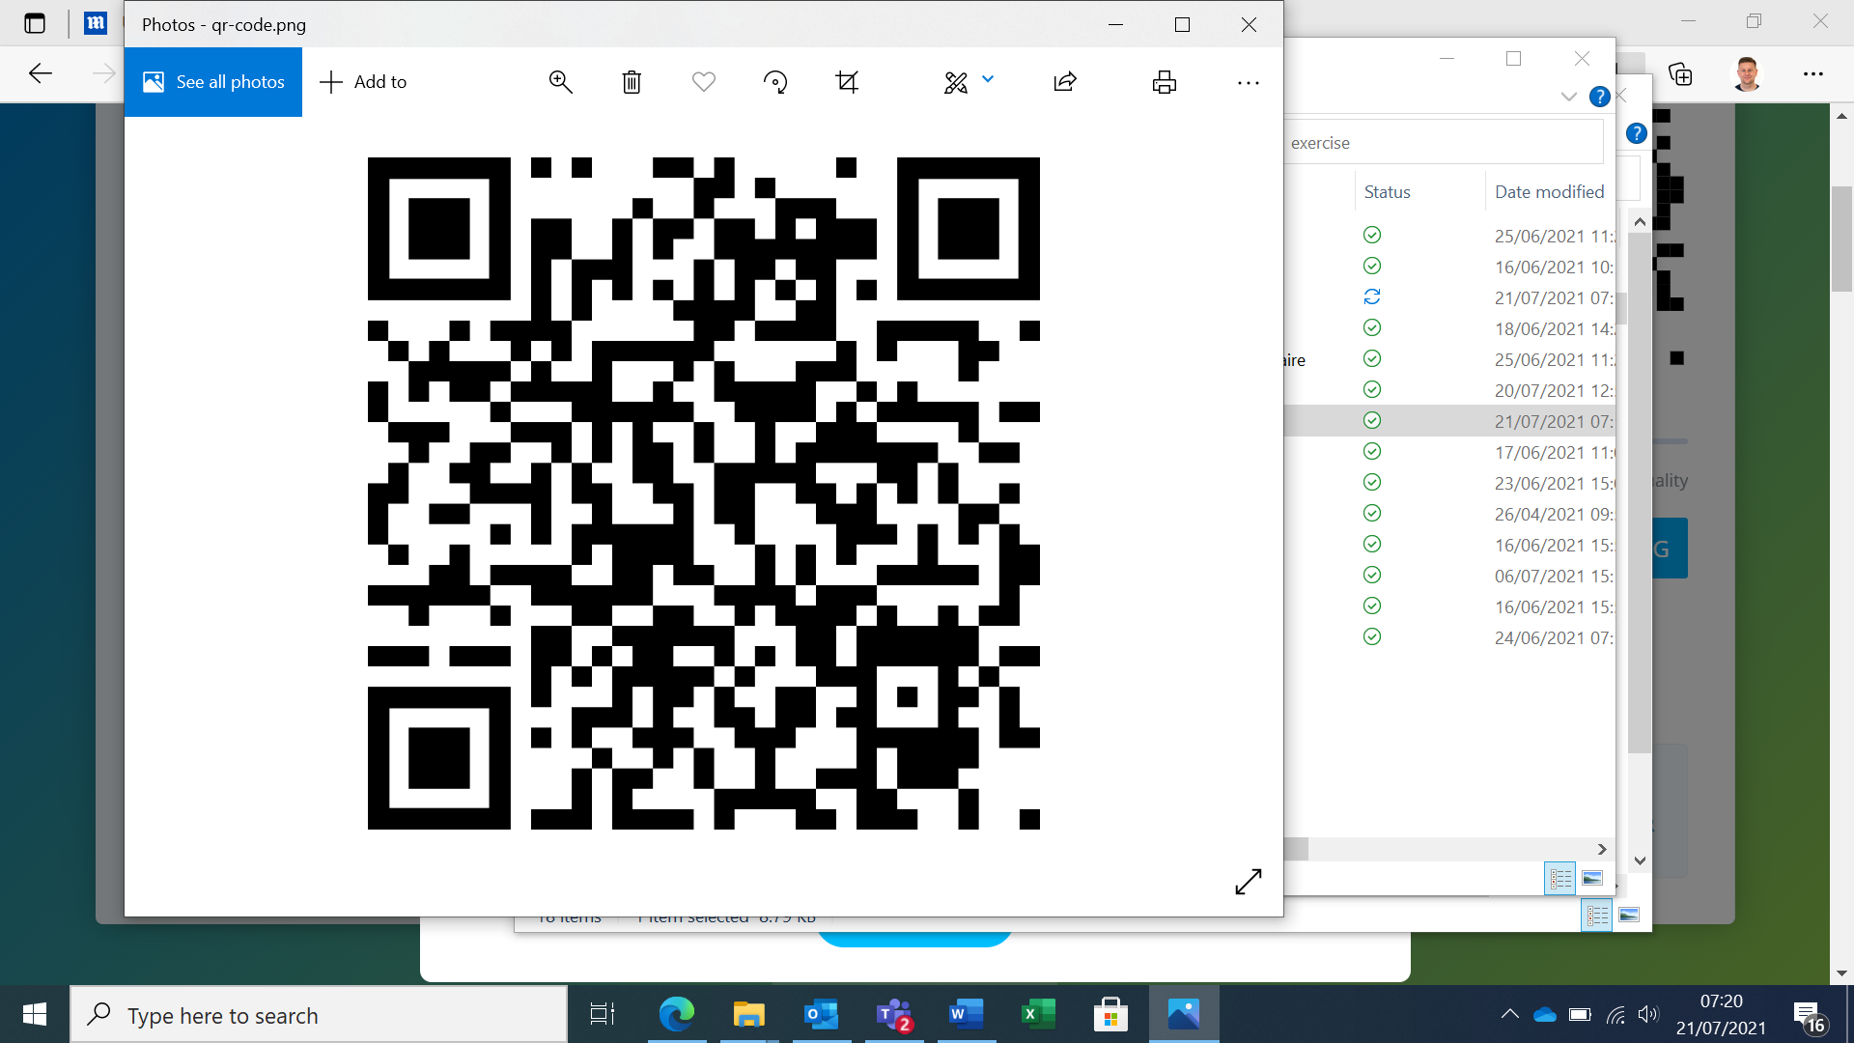

You will access the SNAP survey using your ODS code. This can also be obtained using the following link on the NHS Digital ODS Portal:
https://odsportal.hscic.gov.uk/Organisation/Search

GOS contractors will be able to submit for both the 2019/2020 and 2020/21 financial year’s as contractually required.

This survey has been opened previously from Monday 26 July to Friday 3 September 2021 and Monday 20 September 2021 to Monday 18 October 2021.

Once the form has been submitted the information cannot be changed. There will be a review page to check your answers before submitting the form.

On the form you will be asked to supply the name of the person submitting the data in case of any queries and an e-mail address.

If there are no complaints contractors are required to submit a zero return.

If you have any queries, please contact the NHSBSA Provider Assurance Ophthalmic team via e-mail nhsbsa.paos@nhs.net, their core opening hours are 8.00am till 4.30pm Monday to Friday.

Kind Regards

NHS England and NHS Improvement

