**Annual GOS Complaints National Briefing**

**July 2021**

Under GOS (General Ophthalmic Services) Regulations 2008, contractors are required to complete and submit an annual form providing the number of written complaints received in their practice.

For the 2020/2021 Annual Complaints forms submission contractors are also required to submit a return for 2019/2020, as last year's submission was paused due to Covid-19. NHS Business Services Authority (NHSBSA) will be undertaking this on behalf of NHS England.

The completion of the form will be online via the NHSBSA website. The link to the webpage to complete the form can be found on our website:

<http://www.nhsbsa.nhs.uk/what-we-do/ophthalmic-provider-assurance>.

Alternatively, you can access the link here: <https://wh1.snapsurveys.com/s.asp?k=162446330175> or by scanning the QR code below;

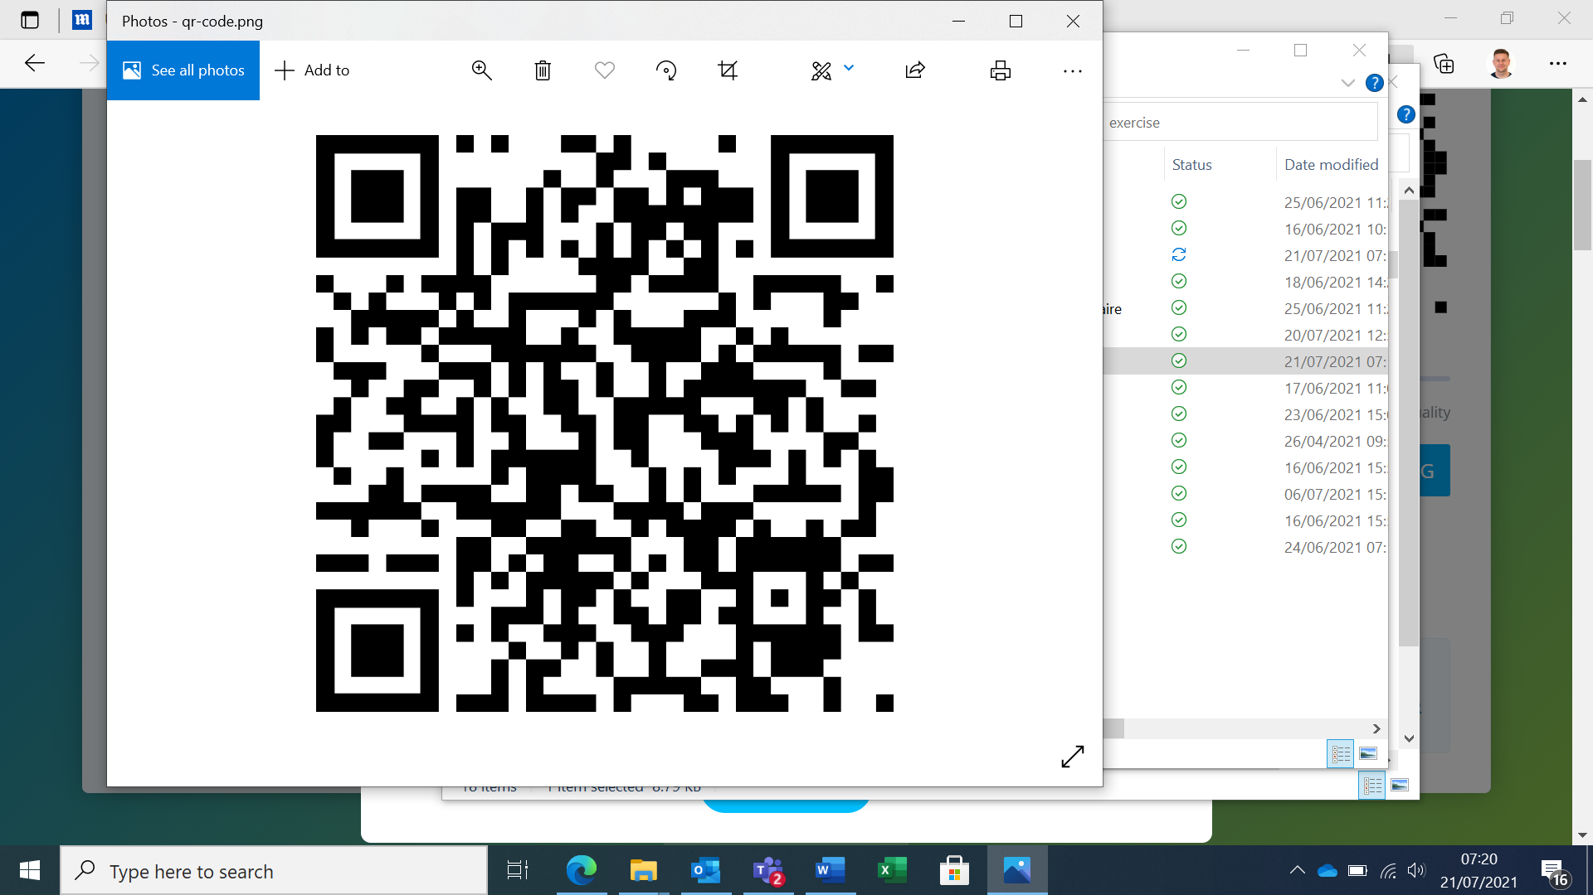

You will access the SNAP survey using your ODS code, This can be obtained using the following link on the NHS Digital ODS Portal:

<https://odsportal.hscic.gov.uk/Organisation/Search>

The survey opens on Monday 26 July 2021 at 9am and closes on Friday 3 September 2021 at 11.59pm.

Once the form has been submitted the information cannot be changed. There will be a review page to check your answers before submitting the form.

On the form you will be asked to supply the name of the person submitting the data in case of any queries and an e-mail address.

If there are no complaints contractors are required to submit a zero return.

The collated information from the completed forms will then be shared with the relevant NHS England Regional Teams.

If you have any queries, please contact the Provider Assurance Ophthalmic team via e-mail [nhsbsa.paos@nhs.net](mailto:nhsbsa.paos@nhs.net), our core opening hours are 8.00am till 4.30pm Monday to Friday.