Prescriber Dispenser Report

When requesting prescriptions from NHS Prescription Services there is certain information we require on the Prescription Search Request Form to assist us in retrieving the correct forms.
The following will show which information we require on the Prescription Search Request Form and provide you with a step by step guide on how to obtain it

NB: ePACT.net is available in a number of different views (monitor, PCT, Hospital Trust etc). This presentation has been produced in a monitor view.
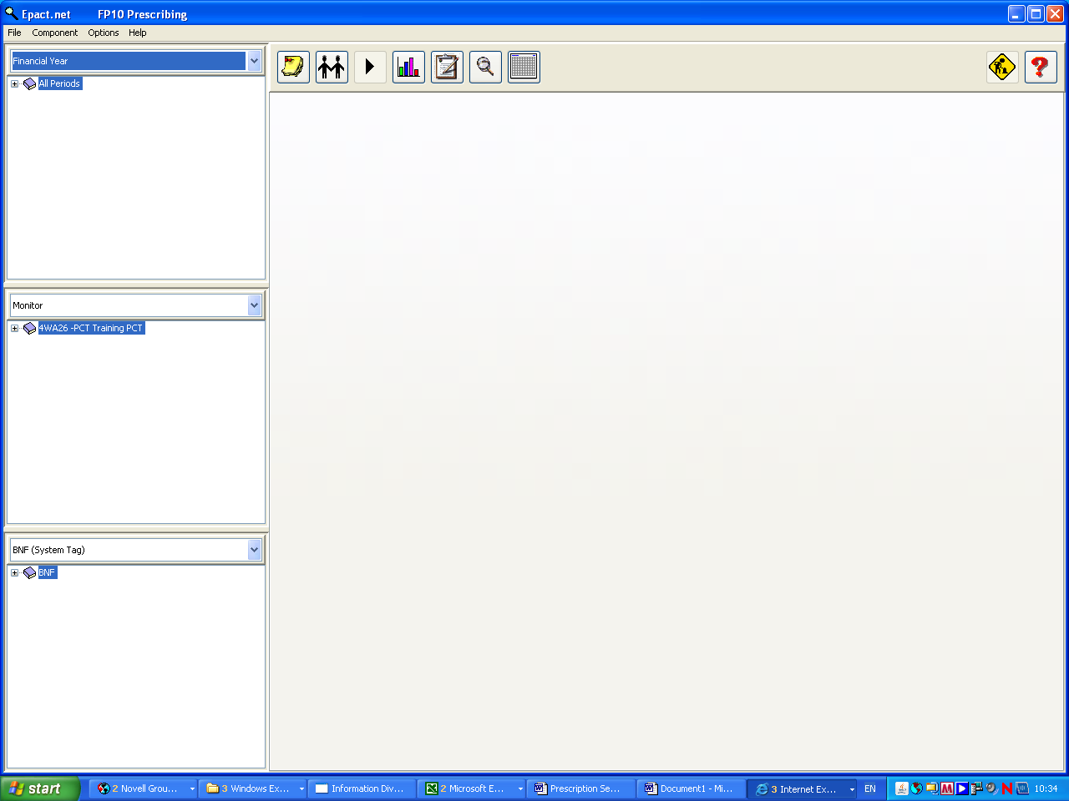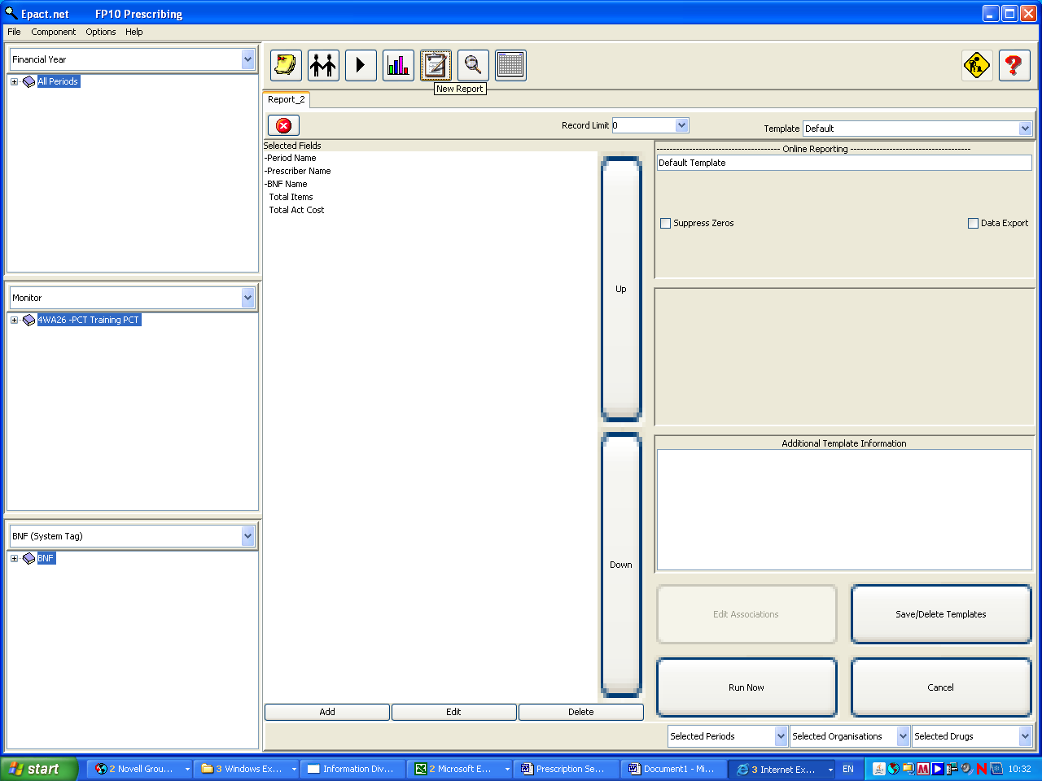
Initial Screen
Select
‘Report’
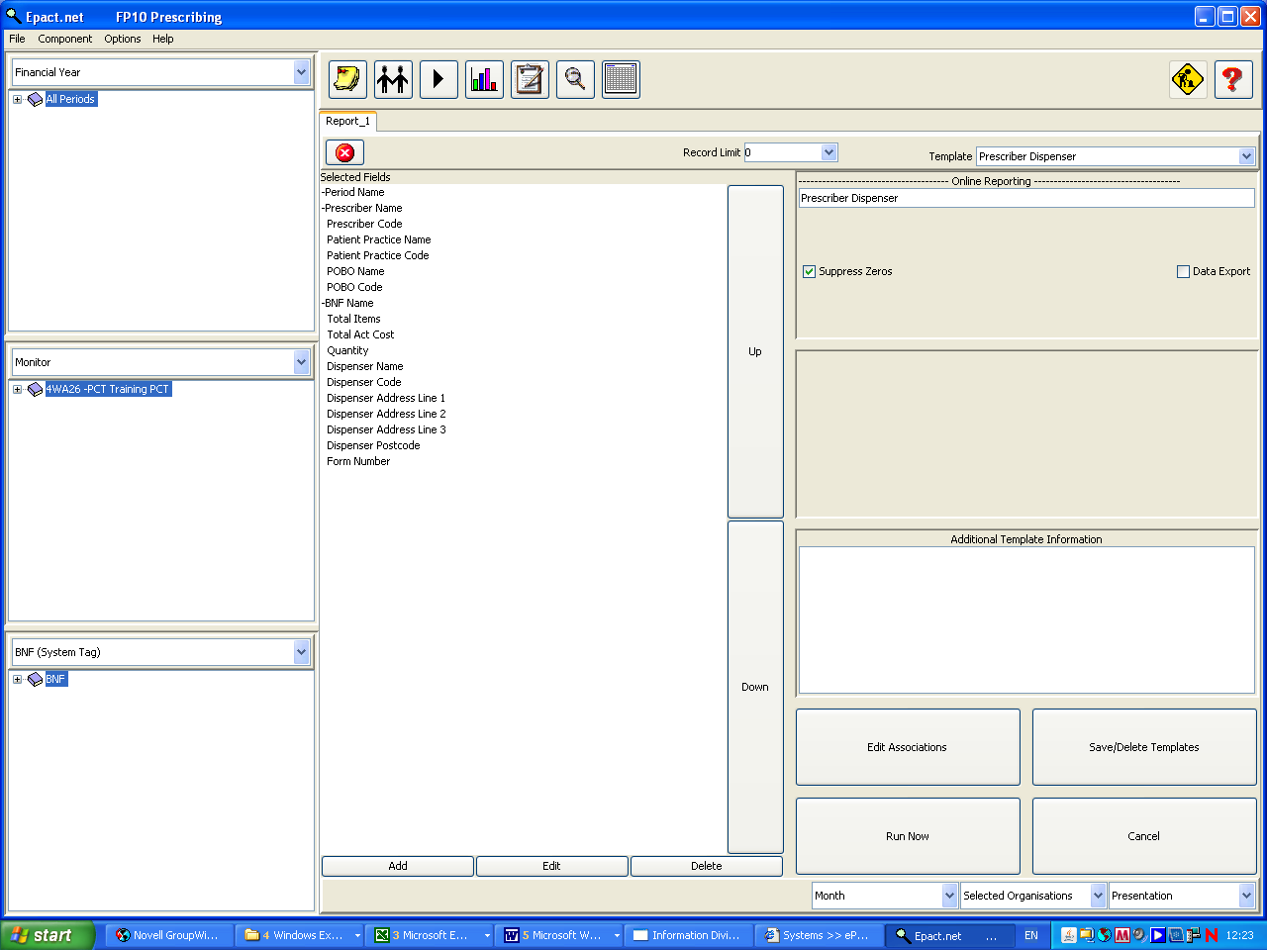
Select ‘Prescriber Dispenser’ Template
Ensure ‘Record Limit’ is set to ‘0’
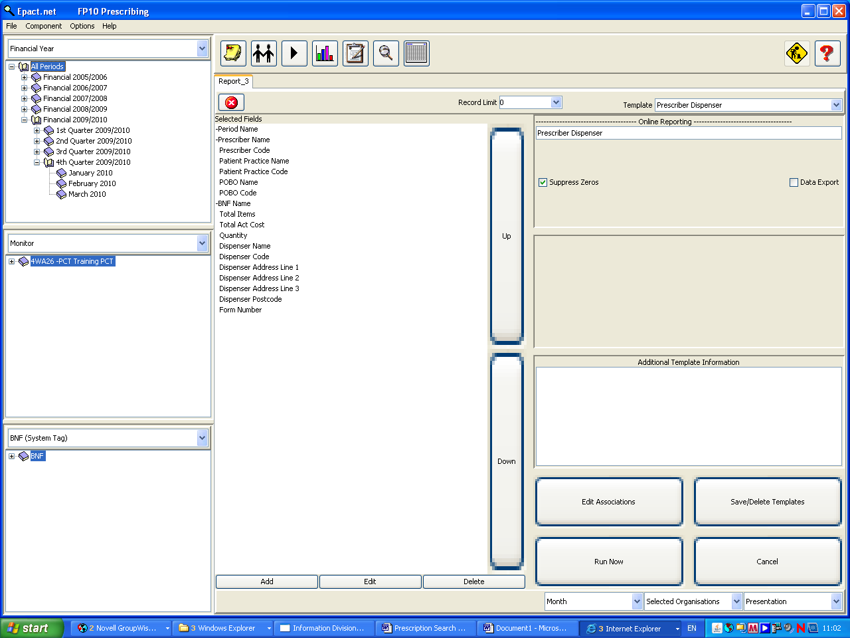
Expand and select the month you require (1 month at a time)
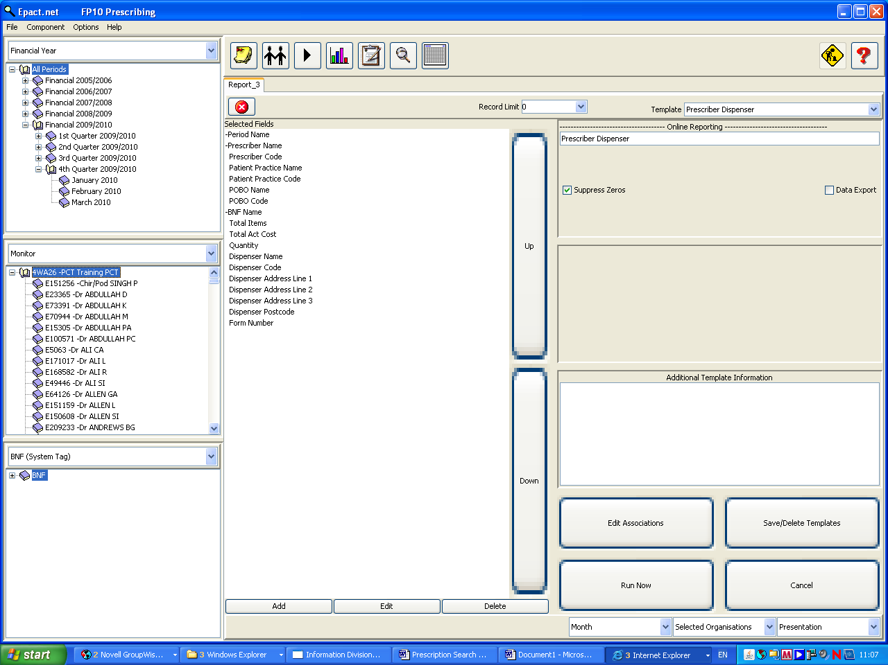
Expand and select the
Prescriber
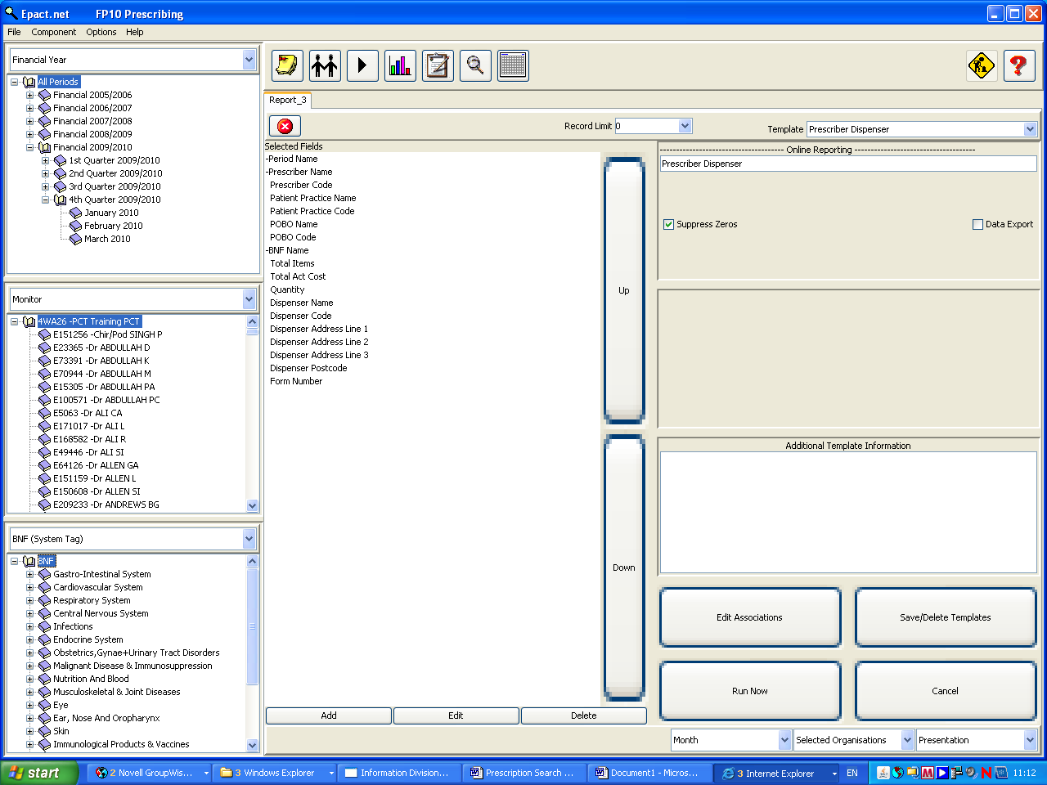
Expand and select the drug
(if applicable)
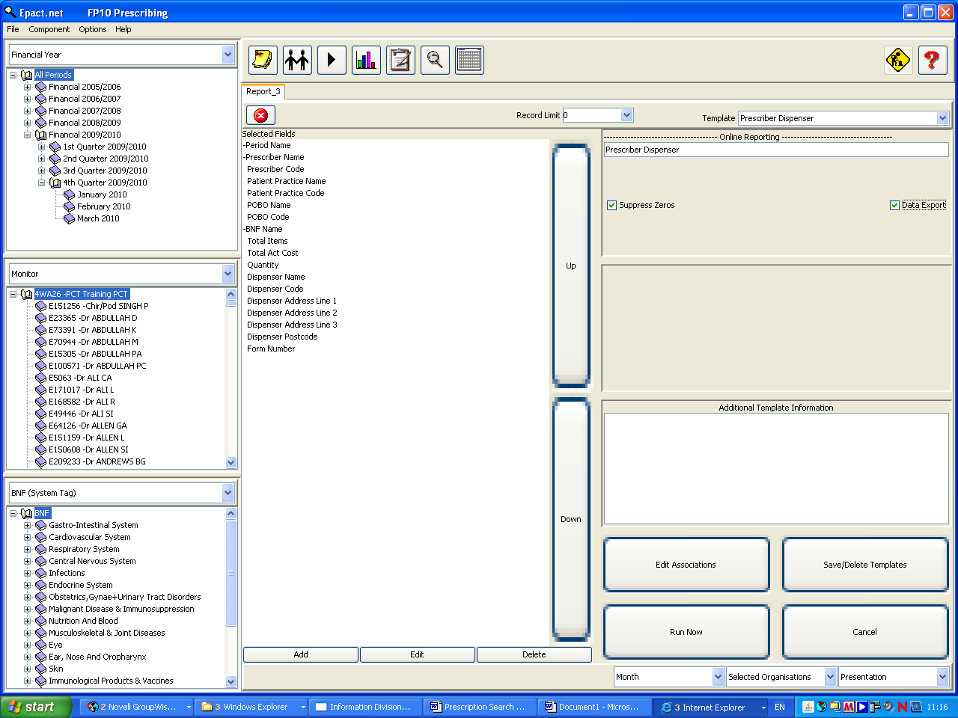
Ensure ‘Data Export’ is selected to obtain the report in excel format
Ensure ‘Presentation’ is selected (should have automatically defaulted to this when Prescriber Dispenser template was chosen)
Is selected
Select ‘Run Now’ to run report
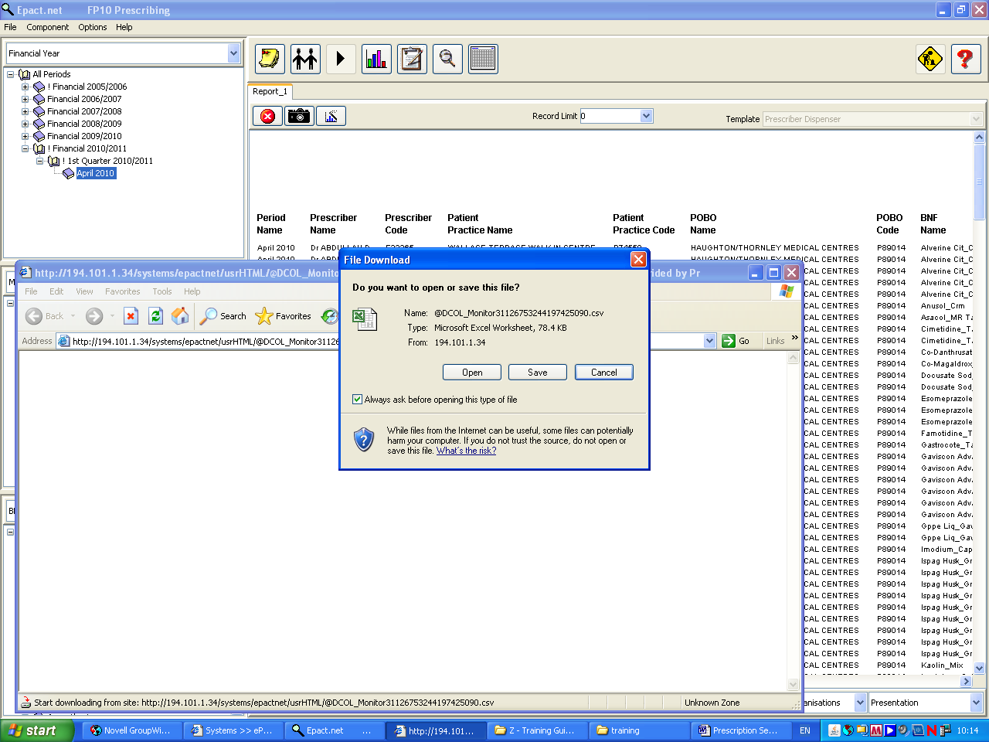
Choose ‘save’ in order to save report as an excel spreadsheet
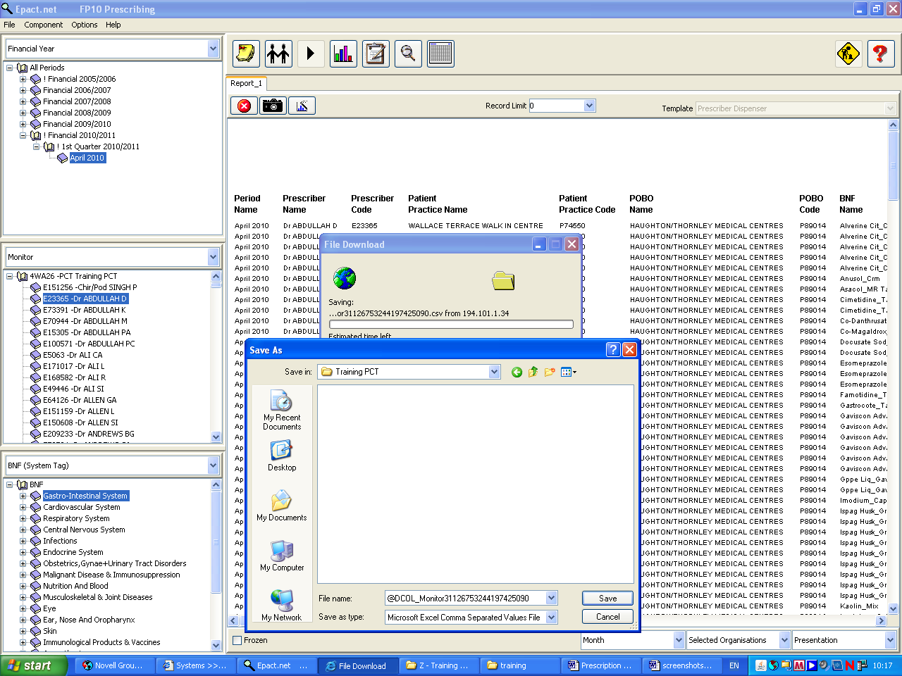
1. Choose where you would like to save the report
2. Rename the report if desired
3. Choose ‘save’

You may wish to forward this report to support the information on the Prescription Search Request Form.

If your prescription search request does not involve all of the forms/drugs showing on this report please delete the rows which are not required but ensure it contains all of the fields from the Prescriber Dispenser template.

Send the completed Prescription Search Request Form/s with the ePACT report if necessary.
The form and guidelines can be found on the following link: http://www.nhsbsa.nhs.uk/PrescriptionServices/955.aspx

