

Information Services Portal

PDPI

(Practice Detailed Prescribing Information)

**Home Page**

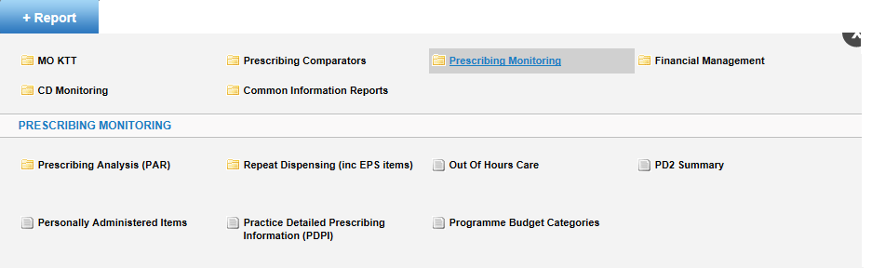

From the home page select *+Report*, *Prescribing Monitoring*, then *Practice Detailed Prescribing Information (PDPI)*. The following page will open;

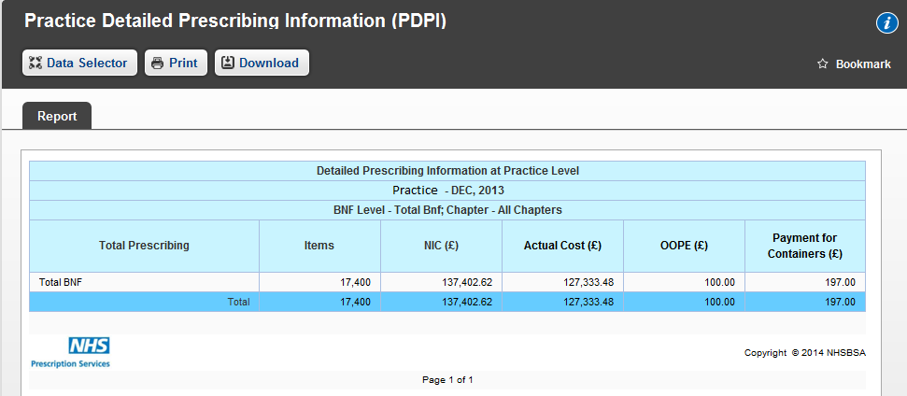

If you are a practice user, the report will open at Detailed Prescribing Information at Practice Level for the most recent month available for your practice.

Select *Data Selector* to change report view and time period.

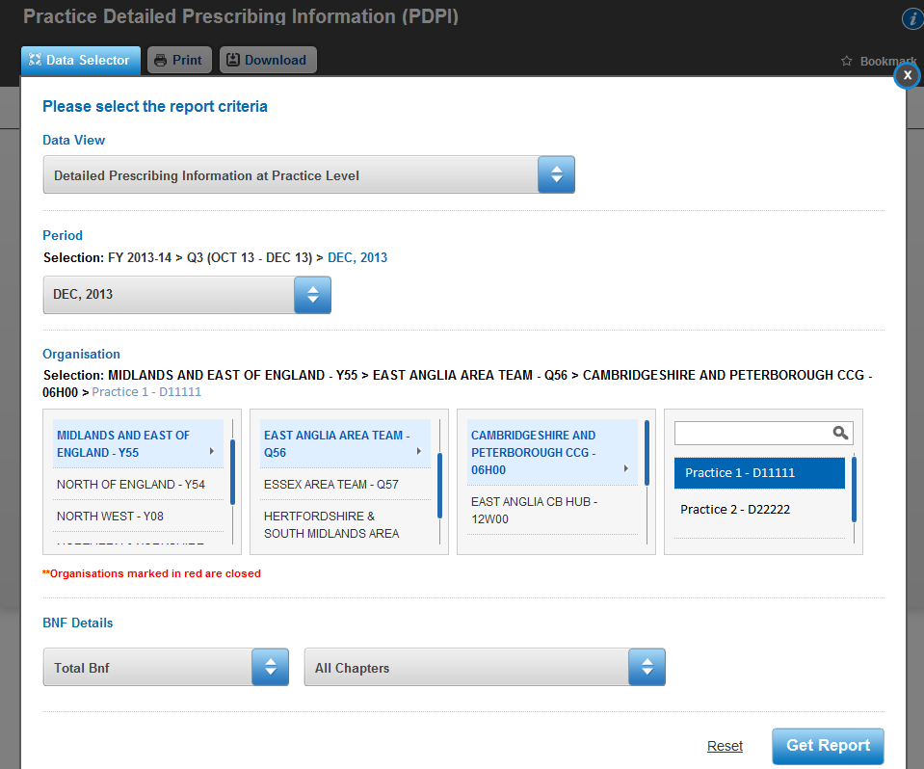

If you are not a practice user the report will open in the *Data Selector*. You will have to choose the practice you wish to view by drilling down from Regional Office through Area Team and CCG and choose the practice you wish to view data for.

You can search for your practice using the search function in the practice box. If you are a practice user your practice will already be selected.

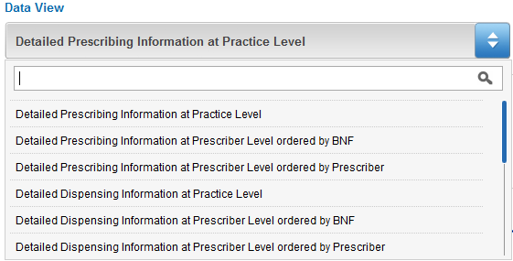

Under Data View you can select different report views.

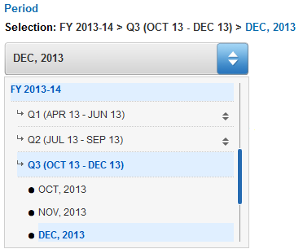To search for a data view type the name, or partial name, of the view you require into the space provided and the drop down box will only show you the views with those characters in the title.

You can select the time period you wish to view. Drill down through financial year and quarter to choose your desired month.

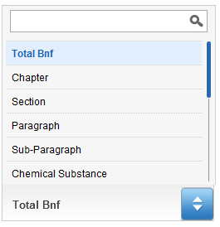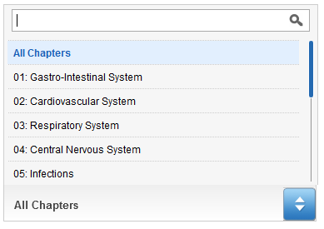

You can select the BNF Level and chapter of the report by choosing the level/chapter from the drop down menus.

You can use the search bar to search for the desired BNF level or chapter.

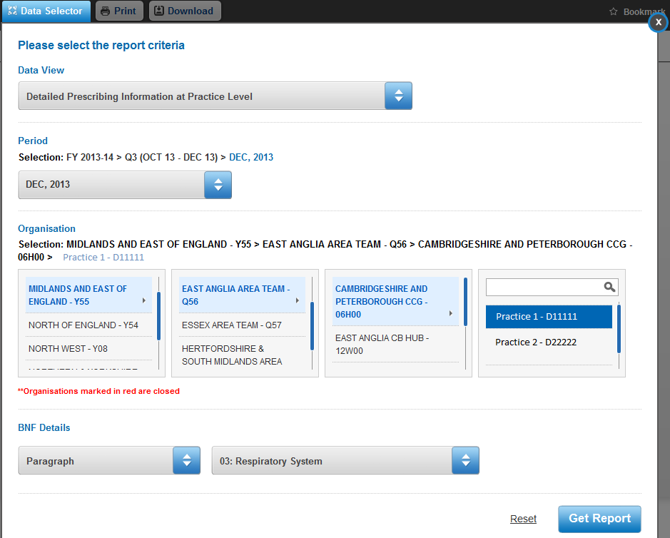

When you have made your selections, click *Get Report* to open the report with your desired selections. If you wish to reset the selections to the default settings, click *Reset*.

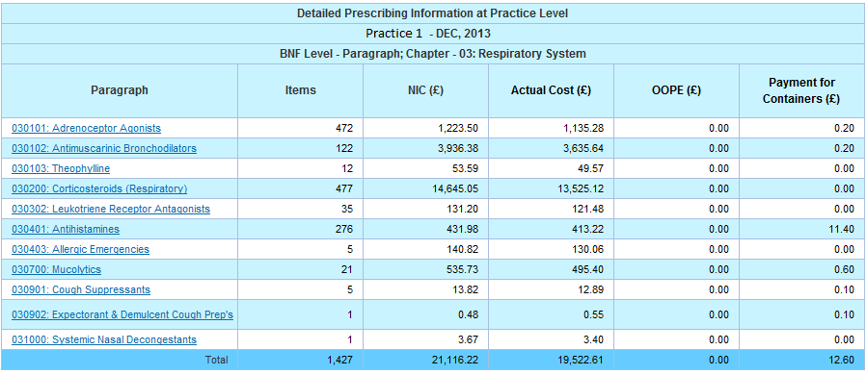

You can drill down by BNF Level. If a heading is underlined, select the heading to drill the report down to the next BNF Level.

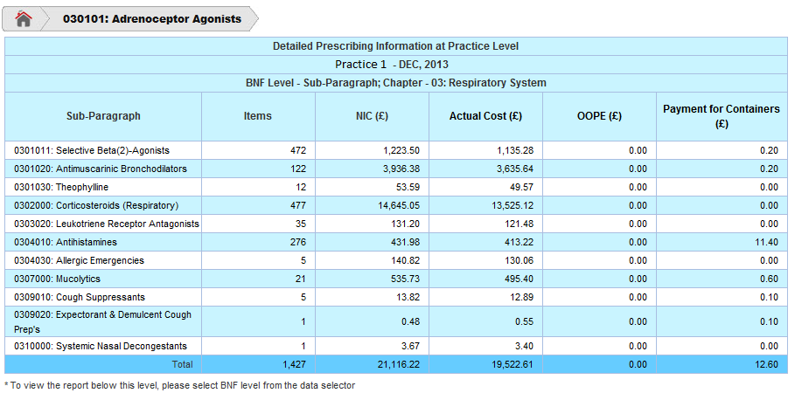

When you have drilled down through a report, a new set of tabs will appear above the report. Click on the appropriate tab to return to that level of the report. Select the home tab to return to the top level of that report.

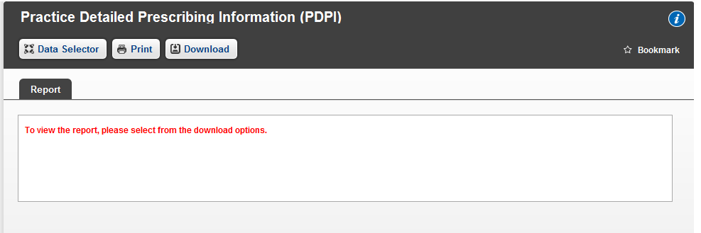

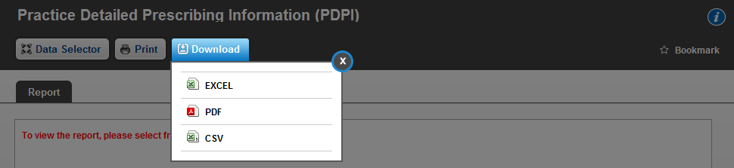If you wish to view a report with a BNF level of Chemical Substance or below, you have to download the report.

To download a report, select the *Download* tab and select which format in which you wish to download the report.

To print a report, select the *Print* tab. For more information on printing and downloading reports, please see the Downloading and Printing User Guide.

To bookmark the report, select *Bookmark*. For more information on bookmarking reports, please see the Bookmarking a Report User Guide.

Select here for more information on reports.